Jan 25, 2016

OK traders - let's begin with ROMAR:
As I have stated when ROMAR is in sync with all three charts the trend is down and I do not recommend counter-trades. But - if one or more of the ROMAR is out of sync you are in consolidation and you can trade BOTH ways. All you have to remember is ROMAR is both support and resistance and you have the 40 pips before hitting ROMAR in the counter-trade.
I hope this clears up the confusion.
I also stated this system is not for everyone. The reason is you are looking at a 6 month period of learning to trade this system with great profitability. If you do not have the heart or the patience then it will be difficult for you.
OK - for one do not entirely depend on the 1 hour for entries. This will get you into trouble. You also have to depend on the 2 hour for the reference on your entry. Right now the 2 hour is still up with the Parabolic and is in a slider with EMA going under purple. Look at the big picture just not a portion. The actual entry for the long was when the market hit the lower BB this morning on the 1 hour; which was in trend with the 1 hour ROMAR.
..................................................................................................................................................................................
Quoting shinny
{quote} If we get conditions for a buy on 2 hour, we could buy a pullback to 1 hour ema?
Yes you can - EMA then becomes support. PROVIDED EMA is support with both Smooth and EMA had crossed Purple.
..................................................................................................................................................................................
Quoting shinny
{quote} Would the pullback need to be all the way to the ema or can we buy if a bar is in the 4 horsemen channel?
What I believe I am hearing is you are looking for short-cuts? There are no short-cuts with this system. The system is attached with the rules.
..................................................................................................................................................................................
Quoting shinny
{quote} No not at all, just clarifying that point
The 4 horsemen channel is the trend. If the trend is up the 4 are support; if the trend is down then the 4 are resistance. Once the variation with one of the horsemen crossing Purple, you are in consolidation with the chart and trading is both ways.
..................................................................................................................................................................................
Traders - as you notice on your charts the bar before the 17:00 the market created a new high at 118.869 - and from that point; the market went into consolidation.
..................................................................................................................................................................................
During consolidation the 2 hour Smooth had crossed Purple and stayed above Purple during the consolidation for the change of trend. You had the 2 hour Parabolic flipped and EMA had slightly crossed Purple. and heading to cross Smooth. Until EMA crosses Purple you are still in consolidation. EMA/Purple crossing is the breakout. Until then do not anticipate.
I have said it once and will say it again: 80% of the market is totally about consolidation.
It is fair to say across the globe there are brokers that compromise the MT4 with their demo accounts. It is sad but true. The only way you can get the correct data is with a brokers live account. This is not say that some brokers will even compromise there live account MT4. This is why it is highly recommended to use an honest broker. And the reason they never get caught because, percentage wise; there are much more losers then winners.
Lets take a look at the moment and tell what you see as for support and resistance:
The Daily;
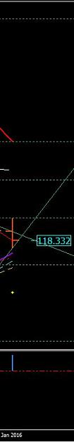
http://www.forexfactory.com/attachment.php?attachmentid=1838974&d=1453762503

The 2 Hour:
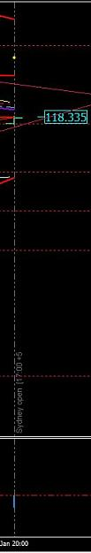
http://www.forexfactory.com/attachment.php?attachmentid=1838976&d=1453762529

The 1 Hour:
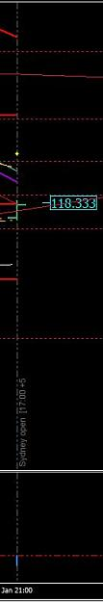
http://www.forexfactory.com/attachment.php?attachmentid=1838977&d=1453762557
..................................................................................................................................................................................
Quoting L1ndgren
{quote} Daily has started a retrace at least, H2 and H1 could be meeting resistance at the 4 horsemen and coming back down. H2 and H1 are in sync but Daily is not. So we are looking at a swing in consolidation on the H2/H1?
You are the closes of being right. But this is where and how your trading plan is created.
We are looking at a developing Daily candle it is showing an uptrend with EMA as support and ROMAR as resistance. The market is above the 4 horsemen which places the 4 as support.

On the 2 hour you have the market below the 4 horsemen as resistance and ROMAR as support.
On the 1 hour you have same for the 2 hour: the 4 horsemen as resistance and ROMAR as support.
So think about this for a moment - without anticipating - and see if you can come up with the right entry.
..................................................................................................................................................................................

Quoting L1ndgren
{quote} On H1/H2, I would put a sell order at the top of the current/next candle and take profit near ROMAR. Then a buy order if it touches ROMAR because that would be resistance on the daily. 40 pip SL on hourly, 100 pip SL on daily.
What makes you ANTICIPATE the market will not break the 1 hour ROMAR?
..................................................................................................................................................................................
Quoting L1ndgren
{quote} I was thinking it might break H1 ROMAR, but not the H2 ROMAR. H2 ROMAR is almost the Daily EMA figure.
Very good - that is correct. It will break the 1 hour heading for the 2 hour in a trend with both.
..................................................................................................................................................................................
Just keep in mind that the Daily does have EMA crossing Purple. But there is one major problem - and that is the Daily EMA has not crossed Smooth for a full blown uptrend. This means consolidation is still on going.
So what this means is the Daily EMA is still in consolidation for EMA to slide over Purple/Smooth for the trend down on the next Daily candle. And this is possible with the 1 and 2 hour in sync for the down.
The entry for this down was the SAR hit at 118.644 on the 1 hour:- Since the candle was developing at the time the SAR was attached to the candle - the entry was right at the Parabolic. And there were 4 - 1 hour candles with the Parabolic hit.
Just remember what I had said about the Parabolic hit and that is on any chart. You take entry with the hit and there are times you will have a great visual with the SAR.
Right here we have an ABC Triangle. A for beginning; B for the top; and C for the finishing.
What this means it could very well keep going to break the pattern by getting below the "A". On the other hand - it could retrace from the "C" and continue up and down until it reverses or break the "A" of the pattern. This is only for future reference.
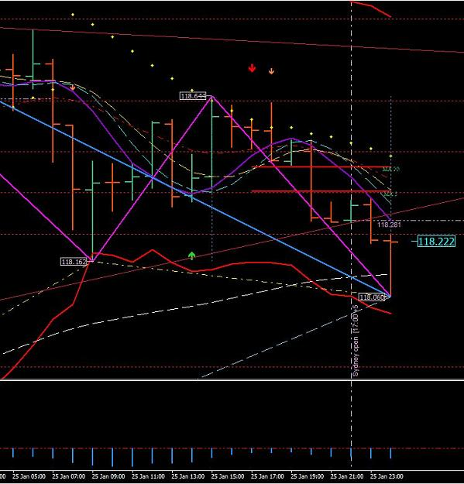
http://www.forexfactory.com/attachment.php?attachmentid=1839023&d=1453768640
And by the way - the pattern had been broken on the LOW of the "C".
Jan 26, 2016
There are some of you that are learning and others are not. For those who are having problems - all you need to do is study, study, and study. Eventually a light bulb will go on. It is like going to college working for a masters degree. It does not happen over night. It takes time.
On your Daily chart take note
Last week it had created a new low with the Fibo flipping for the up. The Fibo is a very good source of information for entries and targets. This up had hit the 38.2 resistance of the Fibo and bounced and did so again yesterday; and continue down for the Smooth support and also the 23.6 support of the Fibo and bounced again.
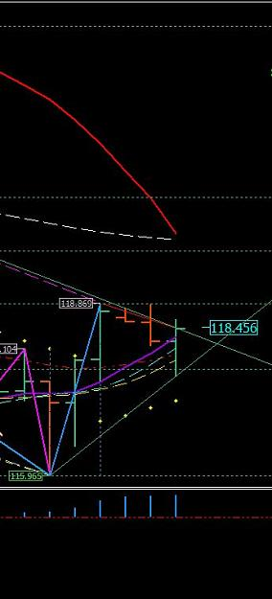
http://www.forexfactory.com/attachment.php?attachmentid=1839791&d=1453826476

On the 1 hour it got below the ROMAR support and became resistance. It then created a new low and turned. But also take note of ROMAR sliding just under EMA. It did not cross EMA so the trend is still up. With this new low there were three entries going up. 20 - 40 pips depending on entry.
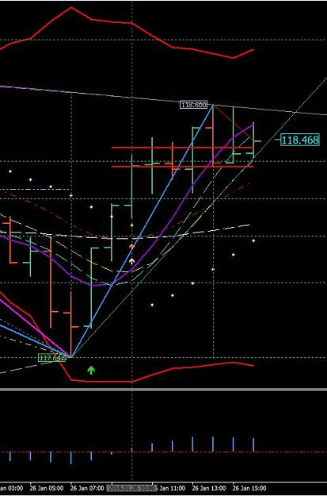
http://www.forexfactory.com/attachment.php?attachmentid=1839793&d=1453826505

The 2 hour is still under EMA for the uptrend which means that 2 hour candle had broken the rule and must return back to trend on retrace; or on the next candle.
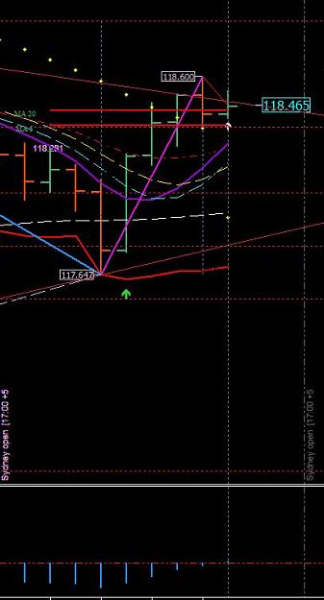
http://www.forexfactory.com/attachment.php?attachmentid=1839797&d=1453826529
Also note the hit on the lower BB of the 2 hour.

OK Traders - let me give scenarios with the ROMAR vs EMA. And the 2 hour chart is the TREND CHART. Not the 1 hour. The 1 hour is your trading chart for the entries. Support and Resistance determines your entries between the two charts:
These scenarios are with the 2 hour chart and you use the 2 hour chart to determine what is happening with the trend. This picture below is showing the market getting above the ROMAR DOWNTREND. This means ROMAR is above EMA for the down and the trend is down. This scenario is showing ROMAR sliding over EMA and the entry was at the OPEN candle below EMA.
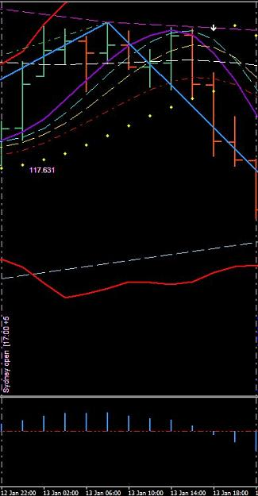
http://www.forexfactory.com/attachment.php?attachmentid=1839895&d=1453832656

On this scenario is the same as the one above. ROMAR sliding over EMA for the down and the OPEN candle below EMA is entry for the downtrend.
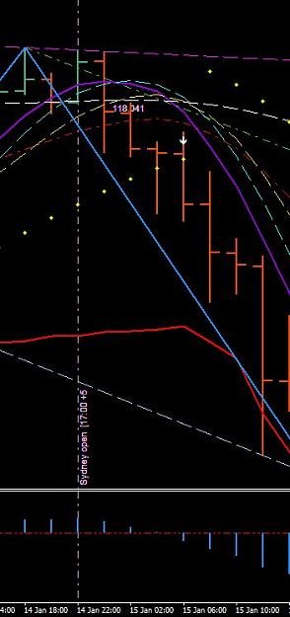
http://www.forexfactory.com/attachment.php?attachmentid=1839896&d=1453832797

On this scenario you have the same situation but ROMAR is at the crossing and just sliding over EMA for the down. Take note of two things.
You have 1; Purple/Whit crossing and 2; with an open candle below SMOOTH showing the crossing of Purple. And that is not anticipating because it is showing the crossing before it even happens.
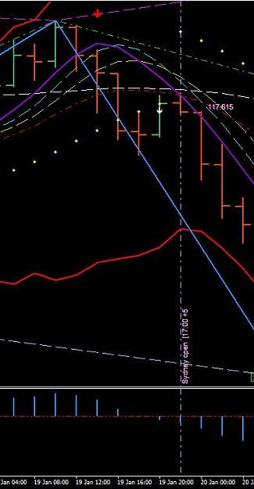
http://www.forexfactory.com/attachment.php?attachmentid=1839901&d=1453833287

On this scenario it is showing the change of trend from the down to the up with ROMAR. Notice ROMAR at the PURPLE WITH the 4 horsemen in the uptrend. The entry was with the open candle showing ROMAR at Purple.
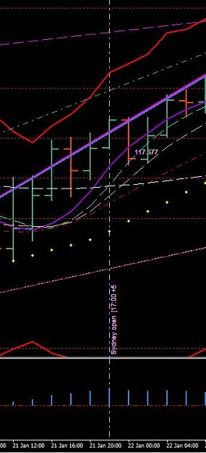
http://www.forexfactory.com/attachment.php?attachmentid=1839903&d=1453833554

The variables with this system for entries are countless. And those variables relate with support and resistance. So try not in getting emotionally depress because you are not seeing it. And those who are trying to make a fast buck with their live account is on the track of disaster. You are letting subjectively control your intellect of learning.
To understand completely - you cannot trade the 1 hour without the 2 hour TREND. If you are trading the 1 hour trend and the 2 hour is not in the same trend - then you are counter-trading.

Example - 1 hour chart:
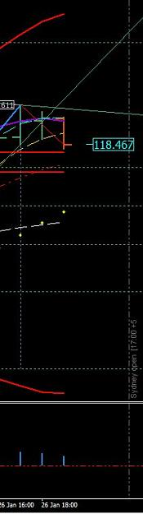
http://www.forexfactory.com/attachment.php?attachmentid=1839953&d=1453837241

Example - 2 hour chart:
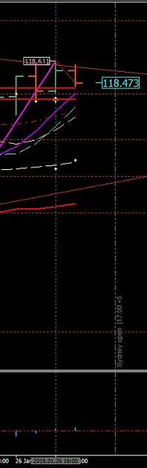
http://www.forexfactory.com/attachment.php?attachmentid=1839954&d=1453837314
The 1 hour is turning for consolidation and the 2 hour is in the uptrend. That means your trades are from support and not resistance on the 1 hour to be in trend with the 2 hour.
..................................................................................................................................................................................Quoting SirViver
Do you mean you would be looking for retracements on the 1hr for buy opportunities, so as to be in sync with the 2 hr trend correct?
In consolidations is pretty much what it means. Your trading from support to resistance and vise-versa. When both the 1 and 2 hour are in trend then you trade strictly the trend.
..................................................................................................................................................................................
Quoting j0si
{quote} Dear Dove, what about this question? Im wondering too. Is there any posibility to place pending orders?
NOT in consolidation. Your pending order can very well go against you for a lost.
..................................................................................................................................................................................
Quoting aazishhunain
Hello Dove sir, I usually wake up late in morning but from the day I subscribed this thread, I'm trying to wake up early in morning to get you online as I'm in GMT+5 zone. I'm continuously reading your thread from start since the first day to get a better understanding. Not being bored I just want to request you that please tell me the hierarchy I should follow to see charts when I open my mt4. Still now, I open daily chart to see longer term trend by seeing Romar and EMA relation and see where market can get support and resistance, then I move...
For those who are outside of the 17:00 EST closing/opening and can not witness it - then you go back to the 17:00 when you open your charts and follow the movements of the charts to the moment. And as you do this you write notes as to what support and/or resistance is being hit to the moment so in your mind; you know exactly what the market is doing - and make your plan from there.
..................................................................................................................................................................................
Quoting GDayMates
{quote} jOsi & Forex Lion, The way I see it, once you understand the system, the most you could have to checkthe charts is at the close of each hourly bar for less than one minute. Even then you will get a feel for if it will be several hours for the possibility of the next setup. Once you have a trade on, you set your SL & TP. So taking this into account it seems a great system for someone who cannot or does not want to watch charts all day. Best regards,
This is very true. You are trading a 2 hour trend chart; which means you have 2 hours in finding a trade. If you check the 2 hour bar at opening and you see no opportunity at that time; then you leave and go do something else and come back to your charts about 5 minutes before opening of the next bar - and you just may see an opportunity at that time when you scan both 1 and 2 hour charts.
..................................................................................................................................................................................
You have to remember traders - you are after 40 pips a day and that is it. And there are thousands of pips running every 24 hour. If you really think about - 40 a day is squat in comparable of how many are running.
While I am thinking about it - in consolidation there are 1; or possibly 2 trades in a 24 hour period. And if the trend is up then the trade is off support. If the trend is down then the trade is off resistance. Just like today. The only opportunity was off the 2 hour ROMAR with the open candle below ROMAR support. That is way it works in consolidation. And remember - the market is 80% consolidation.
In trends with all three charts is a different story (which is 10% of the market). In a downtrend you can get in a trade many times with hits off the 4 horsemen resistance. In the uptrend is the same - off the 4 horsemen support.
This why traders go broke because they have never learned how to trade in an 80% consolidated market.
And I have never heard another trader, on any forum, teach this very fact; especially for beginners so they can recognize just what they are getting into.
..................................................................................................................................................................................
Quoting GDayMates
Mr. Dove, Currently, we are in consolidation, as all three charts are not in alignment. As such, we are trading off of support and resistance. This being the case, would a bounce off the upper 2 hour Bolinger Band be a valid trade? It would be a short and H1 and H2 indicators would be stacked up. However D1 is still in down trend. If I understand this correctly, we would take the short trade, provided we had 20/40 pips back to support (2H EMA) Is this correct? Thank you.
In reality yes. But waiting on the BB hit could be a long wait and much can happen between now and the BB hit. Trading in the moment from bar to bar is the objective. This way you are trading what is happening in the moment and not waiting on something else. The Daily ROMAR is down for the Daily. But you have the 4 horsemen are in trend waiting on the EMA crossing Smooth. So that means ROMAR is the Resistance for the Daily and the 4 horsemen are working for the Resistance. But that too can change from day to day depending on Purple/White.
I hope this answers your question.
..................................................................................................................................................................................
Quoting ForexSamsam
I use on H1 the touch of the Psar and the parabolic as entry pont for a long. The H2 is always in uptrend and the pair goes below the ema support {image}
This was a very good thoughtful and insightful entry. The reason is because he tagged the 1 hour Parabolic and also the 2 hour EMA being tagged in the uptrend. The 1 hour is also still in the uptrend with EMA below Purple. Will he get 20 or +?. The possibility is not great but probability is a consideration. And the reason is because the 2 hour market is below Purple working on a consolidating situation.
If his entry was in a volatile situation then yes -- the probability was great for 20+
But the main objective for his trade is because his entry was right on.
..................................................................................................................................................................................
I have a ministry that keeps me busy with marriages in crises. So there are times I'm on the phone longer then I wish to be.
But anyway - each pair has its own structure according to the pairs and also the market. Some pairs are highly volatile and others are not. And the UJ is one that is not. But for training purposes it is the choice because the pair lacks the volatility and gives more time for the visuals. So next week we will train with the EJ. It is my pair that I trade with and very volatile. And the structure with the EJ is not the same as the UJ.
Basically the trading is the same but the volatility can really put a squeeze on the way you think in terms as a trader. Your thinking has to be recondition in such a term as being "objectively" with support and resistance. If you are subjective with volatility then it can cause a major confusion. And the reason is because your entries are BEFORE the fact with the EJ. Which means you will be looking into the future. And we will get more into that fact next week.

27 Jan, 2016

Being a teacher I have always learned in order for knowledge, wisdom, and understanding to be applied it begins with basic. First I must give a complete revolution of how the system works; and this step is applied with a continuance of references. The next step is witnessing mistakes from the references and make corrections in the direction which the mistake should had not been made. And believe me; this is not easy because of the way people think. So a continuance of corrections or forth going.
This system was built to trade in the moment which is also looking into the future. And the question I always get is how do you trade looking into the future?
Believe it or not - this is not complicated at all. It is the same thing as ROMAR vs EMA I had recently posted. And it is also the same reference as Consolidation vs Trends. So take a look at this tight consolidation we just had after opening yesterday:
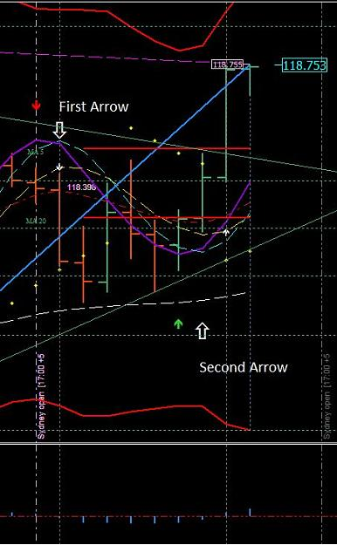
http://www.forexfactory.com/attachment.php?attachmentid=1840823&d=1453914616
The very first step for a consolidation and/or trend is the White crossing Purple. From that point you are looking into the future. The first thing you notice is if the crossing is with the ROMAR trend or is it a counter-trade. This also eliminates the Parabolic support/resistance because in consolidation with the White/Purple crossing; you then have a market up and down. On the picture with the first arrow you had the White/Purple crossing with an open candle below Smooth and just above EMA which was a counter-trade against ROMAR. On the second arrow you had the White/Purple crossing with an open candle above both EMA and Smooth and into the trend with ROMAR. The parabolic's had been eliminated with the White/Purple crossings and that was an entry going into the future.
..................................................................................................................................................................................
Quoting dove_alliance
Traders - we have a new high resistance and the Fibo had flipped for the down.
Until consolidation that new high can be bumped up a few times.
Another reference I would like to bring to your attention. And that is the swing lines. During consolidation those attachment with the candles are a very good source for entries and exits for trading. They may bump a little lower on the next candle for the down and vice-versa. But in consolidation with a 40 stop you are safe.
BUT - in trends; those attachments can move from bar to bar and keep going. So you use those reference for consolidation ONLY.
This also reference the BB's. The hits on the BB's are only for consolidation with the 2 hour chart. Not the 1 hour. Once a trend takes off both upper and lower bands will spread open at a 45 degree for the trend as showing on both the 1 and the 2 hour charts. Just remember your 2 hour chart is the trend chart and you follow the 2 hour for the trend. Your 1 hour is the trading chart in consistent with the 2 hour trend.
So everyone knows: I got out of this trade at the new high from the breakout with the opening candle above EMA/Smooth on the 2 hour. Both charts were in consistent with one another at entry and I seen it before the market even knew about it.
The bottom line traders is recognizing the difference between consolidations and trends. And the basics of recognizing the difference is ROMAR with all three charts. Once you have one of the 3 ROMAR's out of sync with the other two; then you are in consolidation. And unfortunately - the Daily ROMAR is what keeping us in consolidation. So that means you have to use the 2 hour ROMAR trend for the consolidation until the 2 hour ROMAR is consistent with the Daily. Then - you are in trend.
The new high was bumped up a few pips and if you had taken the entry with the new high (in consolidation) you would had made your 40 pips for the day.
Great example of the variables in trading this system.
It is after 17:00 EST and time to reboot. And here is the new data for the next 24 hours. One thing I suggest is after you have rebooted your platform do not reboot until after the next 24 hour 17:00. If you are finished with your MT4 then minimize it to keep it open. If you reboot after 17:00 and then reboot again later - then the data is not correct.
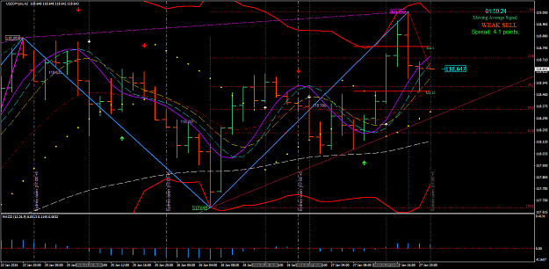
http://www.forexfactory.com/attachment.php?attachmentid=1841010&d=1453932316
OK traders - we have on the reboot with the market between the MA signals. You also have the SAR hit just above the 1 hour parabolic. The 2 hour is in consolidation below Purple with White at the crossing. Bottom line - there are no opportunities for a trade until one shows up.
Just remember you have a new high and the Fibo is set for the down on both charts. And following the Fibo settings for the High resistance and the Low support represents a new target for the low.
Jan 28, 2016

The SAR is a weapon and not being used:
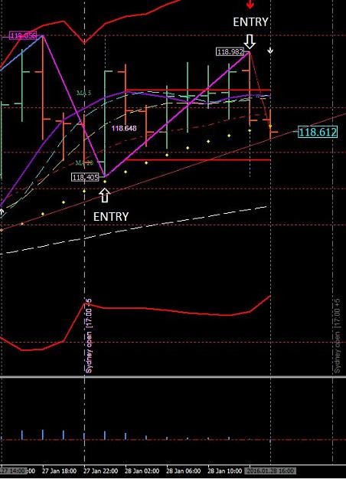
http://www.forexfactory.com/attachment.php?attachmentid=1841834&d=1453998954

What is the SAR saying? Which was entry for the short. And at the moment we are in a very tight consolidation. If entry was with the SAR then your trade was very, very safe.
Like I have said - this is a 6 month process and not overnight. The very first step is learning to trade in the moment which is the very bar the market is on with the 2 hour chart. Once you have visually interpret what is happening on that bar in using all three charts you then are on your way of beating the market by applying the rules. You cannot interpret what you THINK is happening but what is actually happening in real time. And the indicators will tell you what is happening in real time; in the moment. Once you have conquered this quest you will then be looking into the future of is happening; before the market even knows. Some will get it and others will not.
..................................................................................................................................................................................
Quoting shinny
{quote} Ok, so the lower swing high and the close below the EMA on the 2 hour gives us a valid reason to trade down to the next support ie the ROMAR, as we have negated the PSAR right?
That is correct provided you also negated the 1 hour with consistency.
..................................................................................................................................................................................
Right now the 2 hour is in a very tight ranging mode with White/Smooth in a tight squeeze with Purple. And you cannot see this unless you are in the moment.
..................................................................................................................................................................................
Quoting GDayMates
{quote} I shorted after Purple held resistance and current H2 bar broke below EMA. H1 below all 4 horsemen. Daily bar rejected from 38.2 retracement yesterday and again today. Daily EMA below ROMAR. Also MACD H2 & H1 recently turned below zero with white arrows and parabolic flip on H1.
In the moment you have the 2 hour Contour line holding support. If, and/or when; an open candle gets below the problem is over with. But - you still having Smooth and EMA as support in this tight ranging. And this information is in the moment.
..................................................................................................................................................................................
You have to be patient and wait on the 2 hour. Makes no difference what the 1 hour is doing. The trend comes first.
The 1 hour could be showing a small trend with the 2 hour struggling in a tight ranging mode which means the 1 hour is also struggling. Now - the 1 hour could very well turn into the 2 hour trend with Smooth and EMA. That my friends, is the big picture. Patience is a virtue. Wait before you jumped into a trade. Look at the big picture.
If you had taken notice we have been consolidating a very tight ranging for over 16 hours. In this type of ranging you do not want be in there trading. You just have to wait on the breakout.
It is very tough to wait out a situation as we are in now with small ranging. And what causes this? To begin with - the traders in this market could not even budge this market. The market belongs to the Central Banks. And the Central Banks prop traders are the ones that moves this market. Each prop trader is assign when to trade and how much to trade according with the data. And with their trades, depending on much currency they are trading, moves the market. And if the prop traders are not trading then market goes sideways. That is basics.
..................................................................................................................................................................................
Quoting rcbarlow
Thanks, but all I see are the ZigZag lines which are always changing so they can't be used in real time. I must still be missing something. I guess I am just the kind of person that must see something to understand it. Sorry
Trader - you have to recondition the way you think with the Paradox. There is nothing standard with this system of what you have learned from the past. So understanding something new comes from knowledge of what is new. Trying to trade from the old school of thought will only confuse you.
..................................................................................................................................................................................
Alright traders I am back. Being a minister for marriages in crisis is like trying to teach traders to see things in a different light. Very difficult.

So why the trade from the contour line? The answer is because of the Daily 38.2 Fibo. The market has been bouncing off that line since the 22nd of the month. And that will take a missile from a prop trader dropping in 2-3 billion of currency to break it. That is how you get through that wall.

That reminds me. Some of the old timers will probably remember this:
Back in 2005 the Central Banks were pretty radical when it came to trading. It was nothing to catch the E/U in some very sophisticated trends. A 150 pips one in a session and another 100+ pips going the other way in another session. You could catch those trends 2 or 3 times a week. Back then - trading was a dream coming true.
One Friday with the NFP (Non-Farm Payroll) was getting ready to announce; precisely at 08:30 ET the market shot up 372 pips in a blink of an eye; and then back down to the starting point in the next blink; and dropped another 289 pips in the next blink. That was only the beginning this went on for over three hours from one 1 hour candle to the next 1 hour candle for three straight hours. No-one has never seen anything like it. This happened every first Friday of the month for NFP at 08:30 EST for over 6 months. And all we could do as traders is kick back; and watch the show. After it was over we then could get in and pick up the pieces.
One day at 08:30 EST with the NFP show; The banks got so radical with over a 600 pip lightning streak blew up the Main Brain of the Forex. The market was down for 2 days for repairs. That was the ending of the NFP show time.
And by the way that was a pretty good trade from the Daily Fibo resistance.
You are in consolidation and you take the first support down and the first resistance on the up for profit. If you anticipate the market will go further will only hurt you
In time you will come to believe in the supports and resistances of this system. They are stronger than anything you have ever witness.
..................................................................................................................................................................................
Quoting SirViver
Ouch. The 2 hour chart looked like a juicy trade with resistence behind me and ample room down till I reached the romar. When I just switched to the 1 hour after your comment it presents a very different picture. Now it looks like I traded into sar major low point swing. aren't we supposed to be trading primarily off the 2 hr? Where did I go wrong?{image}
You was looking for a trade and did not trade in the moment - If you had of - you would have seen ROMAR support.
..................................................................................................................................................................................
When you trade in the moment with the 2 hour you see a trade in the making you then scan the 1 hour and Daily for support and/or resistance going the other. If you don't - then the possibility of getting caught brings in the risk factor

Jan 29, 2016
Good morning traders - for over 24 hours before the BOJ release the market stayed in a very tight consolidated ranging mode with both the 2 hour EMA and ROMAR in the up trend. ROMAR support trend held and the market could not get below it. And I must say - it has been some time since I have seen a 280+ spike in this market. The probability for this ranging was because of this release. The banks were already set up for the release; and for this kind of spike to happen - it had taken 50-60 billion USA dollars for it to happened. For me - it was very surprising at the release it did not retrace 50 or 60 pips before the spike. It hit ROMAR and that was it for the retrace. So it is very important to never be in a Major news release. So those who were in trade with the release was very fortunate and blessed in not being take out.
There are at least 3 Major news releases you are never to trade in: The NFP release, the USA rate release, and the BOJ release.
..................................................................................................................................................................................
Quoting Contrax
Hello Dana how are you? Goodmorning. Can you put me any homework for this weekend about ur system? I really feel very comfortable doing trades with 40/40 or 20/40. And i know that u are going to be with us this weekend and 1 week more. Can you put us any homework or something to do about ur system? Can we do backtesting or that is impossible because we are trading the present/moment? Thank you! I hope before u leave i can start trading with ur system. Take Care Dana!
Well Daniel - your home work is to study everything I have posted until it is actually part of you. And back testing can be done anytime by turning off the chart's automatic scroll.
..................................................................................................................................................................................
Quoting Contrax
Next week, we are going to work with EURJPY right? And Normally at what time u trade? at 17:00 NY Time, from that hour u start looking for a trade? or u like to trade in the morning? Thank you.
My routine is turning in between 9 and 10 in the evening and up around 4 in the morning. I check my charts for any possibility of any trade. And then get ready for taking care of any business that needs taken care of for the morning. And like this week - I get back and check and read all the postings and give my comments. And then prepare for any training for the day.

And yes - we will start with the EJ next week. Bringing up the EJ is the same as bringing up the UJ. This time - all you have to do is go to New Chart under file and click EURJPY and a new 1 hour chart will appear. Right click on the new chart; then click Template; and then click the Paradox H1 and you you have the Pardox EJ chart.

Bringing up the 2 hour is on the "Open Offline" under File. The Converter is already on the 1 hour template and is in real time so the 2 hour chart for EJ is already there for the offline. Then finish up with the Daily template.
..................................................................................................................................................................................
Let me give you the scenario of what would of happened if not for the BOJ:
Last night you had the 1 hour SAR attached to the 1 hour chart. And on the second 1 hour chart from the SAR was when hell broke loose with the BOJ. If not for the BOJ the 2 hour would had gotten lower/low of the 1 hour SAR and the SAR would had hit the 2 hour candle and the reverse would had happen with the 2 hour ROMAR and EMA support. That is what would had happened if not for the BOJ. So - it was going up one way or the other.
So everyone knows - 85% of the news release is with the 2 hour trend. And the reason is because your Prop traders uses the 2 hour chart for trading.
And no - I am not a Prop trader. But I do have friends that are Prop traders.
..................................................................................................................................................................................
Quoting Contrax
So You sleep 9pm, 10pm aprox And you recommend to trade from 4am NY Time, and trying to collect the 40pips. We are only trading EURJPY next week, and in the future u only recommend just trading one pair right? (Do u trade more pairs or only EJ)? Can u recommend any broker? (I think this is important because some brokers have a very bad data... , and maybe the indicators can show different things.. but really i dont know). Thank you Dana, and sorry if im going to ask a lot of things. I want take the maximium that i can from you before u leave again....
Under no circumstances will I EVER trade multiple pairs. If you want to bankrupt yourself then trade multiple pairs. As for recommending a broker is something I do not do. You have to do your own due-diligence as for brokers.
..................................................................................................................................................................................
OK traders - it is coming up on end of day and end of week. Sacrifice and spend the week-end studying this weeks training. You will need too in order to trade the E/J. I will be working on next weeks training with more screen shots and information.

Jan 30, 2016

Trading is a threshold of owning your own business. It is your life; your profession, and no-one is going to take care of your business accept for yourself. To be successful with your business you must have rules and a passion in seeing your business making profits.
Owning your business in a new profession you must first learn the structural components of that business in such a way; that profits can be accumulated to be successful. And trading is no different. You may have the passion but it too is useless if the desire in learning is lacking. Your own intellect can only accomplish with what knowledge you have gain with the structural components of trading. If you are lacking knowledge then your future with the business is a failure.
There are several components with the structure of trading. And today I will start with the first one.
A daily trading plan:
A daily trading plan is the most important element for the start of your day, as you sit down with your trading station. And the question I ask: How can you trade without knowing whats happening in the market? And the answer is you cant. You can sit there for hours on end and miss the entries without the knowledge of what is truly happening. Your own thinking and intellect is powerless without the knowledge first.
I will give several trading plans as scenarios so you may gain the knowledge in what you are looking for. To begin with; place your plan on word or note pad so you can print it and place it right there next to you on your trading station. This plan is your reference and you will need it until you reached your profit.
This is what my template looks like to create my plan.

DAILY CHART - DATE:
ROMAR:
EMA:
Parabolic:
NOTES:

2 HOUR CHART:
Opening:
ROMAR:
EMA:
Parabolic:
NOTES:

1 HOUR CHART:
ROMAR:
EMA:
Parabolic:
Notes:
Entry:

To be fair I will be using my actual trading charts for the MT4. My charts are with ROMAR, EMA, the 4 horsemen, and Fibo with only the MACD zero crossing for an alert. And the reason is; because I can read into the future. And you need to get to that point with your charts so you can also do the same. So until then; leave your charts as is.

We will start with the Daily. The Daily chart is only reference for support and resistance.
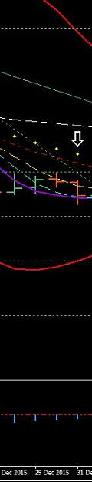
http://www.forexfactory.com/attachment.php?attachmentid=1843253&d=1454124364
DAILY CHART - DATE: 12-30-15
ROMAR: Resistance
EMA: Resistance
Parabolic: Resistance

NOTES: All three support/resistance are in compliance for a strong downtrend.

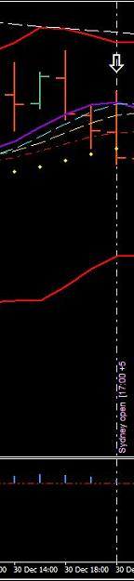
http://www.forexfactory.com/attachment.php?attachmentid=1843254&d=1454124435
2 HOUR CHART:
Opening: 120.499
ROMAR: Resistance
EMA: Support
Parabolic: Support
NOTES: The 2 hour is in a swing with White at the crossing of Purple and eliminates the Parabolic as support. Smooth and EMA are shallow for the crossing with Purple. The daily is showing a strong trend and the 2 hour is showing the crossing of purple with opening at EMA.
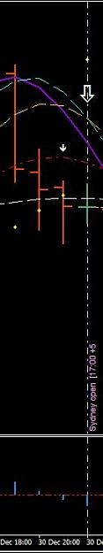
http://www.forexfactory.com/attachment.php?attachmentid=1843255&d=1454124472
1 HOUR CHART:
ROMAR: Support
EMA: Support
Parabolic: Resistance
Notes: The 1 hour had finished the upswing with Smooth in the daily downtrend. The signal for the zero crossing had shown with the previous candle. The Parabolic is already in the downtrend as resistance. Both ROMAR and EMA are at the crossing of the Purple that is already strong for the downtrend.
Entry: The 2 hour is showing the Parabolic as support but also eliminated with the White/Purple crossing. It will take the hidden LR to flip the parabolic and with the down being strong I will take entry with the next 2 hour open candle and/or, the retrace toward the parabolic.
++++++++++++++++++++++++
And on the next candle is where I made my entry for 40 pips.
Now my question is: Would I have seen that entry without my trading plan? The answer is no because I would not had seen it without my trading plan. I would have still been looking for an entry.
OK lets move on to an uptrend.
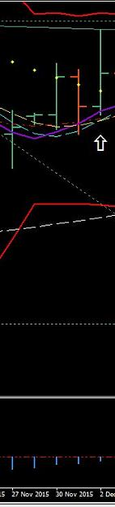
http://www.forexfactory.com/attachment.php?attachmentid=1843256&d=1454124794
DAILY CHART - DATE: 12-01-15
ROMAR: Support
EMA: Support
Parabolic: Resistance
NOTES: On this daily is showing an ending of a swing consolidation with ROMAR as support. White/Smooth had crossed Purple and is support with EMA at Purple for support on the uptrend. The Parabolic had been eliminated as resistance with the White crossing Purple. The upper Bollinger Band is within striking distance for a hit.
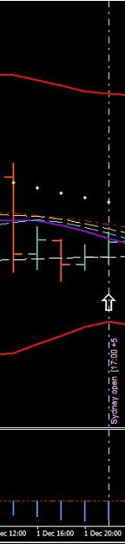
http://www.forexfactory.com/attachment.php?attachmentid=1843257&d=1454124832
2 HOUR CHART:
Opening: 122.848
ROMAR: Support
EMA: Support
Parabolic: Resistance
NOTES: The market opened on top of ROMAR support with EMA on top of Smooth/White in a consolidated shallow swing. The parabolic is also holding resistance.

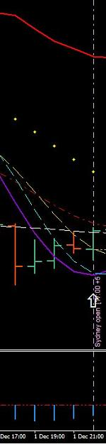
http://www.forexfactory.com/attachment.php?attachmentid=1843258&d=1454124860
1 HOUR CHART:
ROMAR: Support
EMA: Support
Parabolic: Resistance
Notes: ROMAR is sliding under EMA in holding EMA as support with the white crossing.
Entry: According with the Daily chart the swing had ended with White, Smooth, and EMA crossing purple for the ROMAR uptrend. The 2 hour is very shallow with EMA, Smooth, and White very tight. And the 1 hour is finishing up its swing. With ROMAR holding support just under the 4 horsemen and resistance being tight above ROMAR; the best entry would to wait for an open candle above either Smooth or EMA. Which ever come first? That places market above purple for the uptrend.
*******************
It was the 2nd 2 hour candle after my trading plan that opened above Smooth and took entry. And that was a 40 pip trade.

Lets move on with a consolidated trading plan.
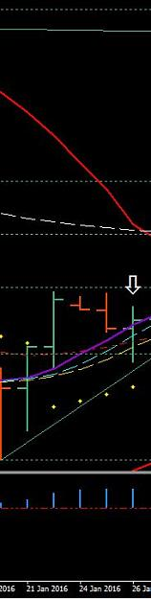
http://www.forexfactory.com/attachment.php?attachmentid=1843259&d=1454125024
DAILY CHART - DATE: 01-26-16
ROMAR: Resistance
EMA: Support
Parabolic: Support

NOTES: The Daily has ROMAR as resistance with EMA crossing purple as support which places the daily in consolidation. The 4 horsemen are in the uptrend in this consolidation.

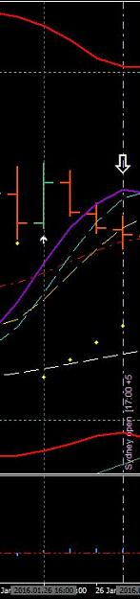
http://www.forexfactory.com/attachment.php?attachmentid=1843260&d=1454125052
2 HOUR CHART:
Opening: 118.398
ROMAR: Support
EMA: Support
Parabolic: Support
NOTES: The 2 hour is turning for a swing in consolidation with opening at Smooth. Open candle below purple.
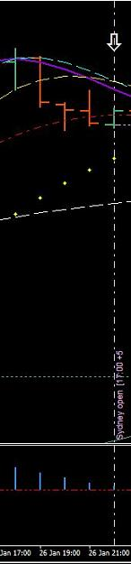
http://www.forexfactory.com/attachment.php?attachmentid=1843261&d=1454125079
1 HOUR CHART:
ROMAR: Support
EMA: Support
Parabolic: Support
Notes: The 1 hour has White/Smooth crossing for the down with open below EMA and in the swing.
Entry: This consolidation could very well go on for hours; especially with ROMAR holding support on both the 1 and 2 hour charts. The risk for a short is more then I desire to take because of the Daily 4 horsemen in the uptrend. The entry would be between the hit on the 2 hour ROMAR or; waiting for the reverse of the swing for an open candle above EMA in trend. Counter-trading ROMAR at this time with the Parabolics as support but eliminated still places the risk of not hitting ROMAR.
So - on this plan I will wait until after I have rested and see what tomorrow brings.
******************
The next day I was blessed with the entry on the 2 hour 07:00 EST candle with the open ABOVE the EMA support; 40 pips taken.
As you can see a trading plan is a weapon in beating the market. All you have to do is make your plans just as I had shown in what to look for. You get your supports and resistances in place with all three charts; on each chart - under notes - you write what is happening in the moment. And then put it all together in what the charts are saying to you.
Also notice the plans are made at the 17:00 EST with the new data. This does not mean you cant make a plan with either London or the USD opening. But be sure the data has been running since the 17:00 EST.
Last month I had switched from the EJ to the UJ in preparing for training with the UJ. So these trading plans were in real time.

Let me now try to bring it all together as a visual on the charts. You have to always remember That ROMAR is trend on all charts.
Long term trend is ROMAR on the DAILY. And what determines ROMAR as trend (on all charts) is when ROMAR crosses EMA. So lets say ROMAR is holding support for the UP and then crosses EMA; ROMAR then changes from Support to Resistance; such as on the Daily. If you look on your Daily you will see where ROMAR crossed over EMA from Support to Resistance.
In order for the Daily ROMAR in becoming support once again; it must cross over EMA for that to happen; this also true on all charts. And because the Daily ROMAR is Resistance and the 2 hour is Support we are in consolidation. Which means the market is in a continuance swings of ups and downs.
EMA is the secondary trend with the swings for the charts. And with a consolidated market EMA is always in and out of support and resistance. And what changes EMA from support to resistance and vise-versa; is crossing Purple. And it is a daily routine with EMA in consolidation with continuance swings.
The picture below is the 1 hour and gives a detail example of EMA. And the 4 horsemen will give you the opportunity for entries.
Starting from left of the chart you have "EMA Crossing Purple". And when you are trading keep in mind what the Daily is saying to you with your Trading Plan.
Coming out of the upswing you already had Smooth as a slider over purple with White crossing into the downswing. EMA is tight with an open candle below EMA changing from support to resistance in crossing purple. You also had the lower band with ROMAR as SUPPORT and ROMAR is out of the trading area. Trading area is between the bands. Which means it would be almost impossible for a hit on ROMAR being outside the trading area in consolidation. So it hit the band and retraced back to resistance.
Next: "White - Crossing - Purple".
You have the White crossing Purple for another swing. EMA is resistance and so is the Parabolic's. But the Parabolic is ELIMINATED.
Let's get a better understanding of what it means for the Parabolic to be eliminated. Once White crosses Purple with the parabolic opposite of the crossing; one of two things will happen in consolidation.
One: it will bounce off the Parabolic.
Two: The market will break the Parabolic with an open candle on the other side of the Parabolic.
If it bounces the Parabolic will stay in trend. If the market breaks the Parabolic the Parabolic will flip on the next 1 or 2 candles. That is what being eliminated means. You do not know what will happen with the Parabolic until it happens.

Next: "EMA - White - Smooth - Parabolic".
The Parabolic's held as resistance with the market bouncing off the Parabolic's and is now in the downtrend against ROMAR support with ROMAR coming back into the trading area. You have an open candle below both EMA/Smooth as resistance; and the 4 horsemen are set for the trend down.
This is the 1 hour chart and is not the same as the 2 hour. This means the 1 hour ROMAR will be hit first and then the 2 hour will be next. If the market bounces off the 1 hour ROMAR then that is it; if the trend is not strong enough for the continuance of the 2 hour ROMAR. In this situation the 4 horsemen are strong in the trend with White showing no crossing. So the market continues on for the 2 hour ROMAR. In this trade the market got below the 2 hour ROMAR as SUPPORT and closed as support. On the next 2 hour open candle the retrace back across the 2 hour ROMAR Support was automatic. And the reason is because the 2 hour ROMAR (IS) support until crossing its own EMA.
NEXT: "ROMAR - EMA - White".
You now have the White crossing Purple to end this swing. ROMAR is still Support and the market must get above ROMAR as support. EMA is resistance and sliding over ROMAR for the support. The Parabolic was eliminated with the open candle above the Parabolic and flipped on the next candle. The entry for this 1 hour was with the 2 hour open candle below the 2 hour ROMAR SUPPORT.
Next: : "White Crossing Purple".
The White crossing Purple had ENDED this swing up. The next open candle was at the crossing and was also entry for this swing down to ROMAR. And the reason is because White had automatically changed from support with the Purple crossing to resistance; and the Parabolics had then been eliminated as support.
Spend a lot of time with this post and structure what is happening with these indicators. This post is the only way you will beat the consolidation. And that is understanding what the Paradox is saying to you. Gain the knowledge and use it.
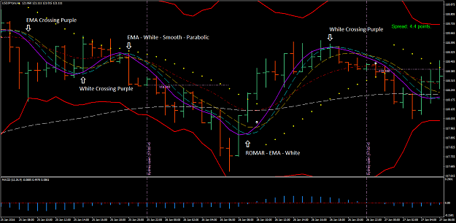
http://www.forexfactory.com/attachment.php?attachmentid=1843516&d=1454183124
Here are the three charts for EJ:
At this time I am giving away the secrets of positioning trading. Positioning trading is done on either the 2 hour; or the Daily; or even on both charts. The reasoning is because you have both alert and visual on the charts for entries and exits.
Positions trading are done from the high to the low and vice-versa. And there are a couple of ways to trade positions.
Position trading takes a lot of heart in watching your profit being taken on the retraces. And most traders will take their profit as they are watching it being taken; and have no idea what to do next. The example of positon trading is on both the 2 hour and the Daily of the charts below.
On the 2 hour you have a Low at 128.240 and a High at 132.276; for a total profit just over 400 pips; and taken in a 2 day period which is two weeks profit for trading 40 pips a day. And I admit; we had a 271 pip spike on the EJ; included between the high and low. But the fact is it did happen. So, it is included.
Also take note of the SAR on the 2 hour. When it showed 129.467 as a high; you could do one of two things. Take profit and reenter at the low of the SAR at 128.93; and youre back in for the long. Or; let it ride on the retrace to the low of the SAR and add more funds (provided you did not use up your margin) for another entry long. This way you regain the loss on the retrace.
If you want to be a real lazy trader with nothing but free time; then on the Daily you have a high of 132.787 and a low of 126.156 with a profit of 663 pips. I believe you now have the big picture. And you work the SAR with the Daily as the 2 hour.
This is known as Positioning trading. And it all begins with the flip of the Fibo. This is something I suggest beginner traders take a good look at; and even the old timers that are still struggling. This may be your answer for trading.
I have two trading accounts one for intraday and another for position trading. After the end of the week I will become strictly a position trader. I will become one of those lazy traders.
And by the way I do not watch the profit being taken I just let it ride with my charts close and check it daily with the 17:00 EST Daily candle.
Daily:
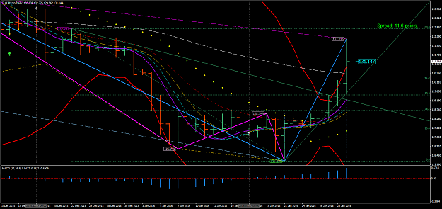
http://www.forexfactory.com/attachment.php?attachmentid=1843546&d=1454197405
2 hour:
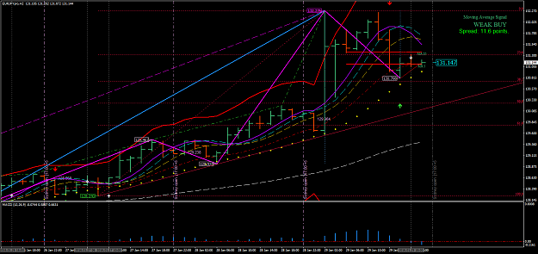
1 hour:
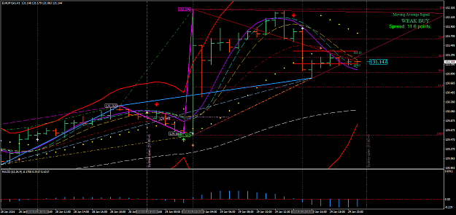
Jan 31, 2016
Hello Traders. You are now trading a very volatile pair. The EJ is in consolidation because the Daily ROMAR is resistance and not support. And if you was paying attention you would know why. Last week there are traders that had made substantial profit without any losses. But I must admit - they are traders that has been around for awhile. But the main objective is they payed attention in was being taught. So, they were able to get it.
..................................................................................................................................................................................
Quoting L1ndgren
{quote} Hi again Dove, I do have a question. How often do the SARs reattach to subsequent candles?
It all depends on the Data.
..................................................................................................................................................................................
Quoting woww
{quote} i'm still leaning , I have very difficult with language...so Daily touch BB and seems to go down H2 has white cross smooth confirming direction but EMA resistence is very near (<20) H1 has purple cross withe in direction UP so I think I wait the confirme on down whit H1 in accordance whit H2. correct me if Im wrong. P.S. I dont also understend the SAR utility.
Creating a trading plan is on what you see in what is happening with the market. And you may see it differently than me. Everyone is different. So you have to practice at creating a plan for it to work for you and not someone else.
..................................................................................................................................................................................
Quoting Timo7
Hi, yes I have a question. Do you set the stop loss at 40 pips and just leave it there, or do you bring it to break even at some time, if so, what is the criteria of bringing the stop to break even? And, what is the difference, if any, between Ninja 7 and MT4 system. Do they both give the same results with your Paradox System?
The B/E is set after 15+ pips of profit because if you are less then 15 pips the chances of being taken out with B/E is greater then above. And with the E/J I would go 20 profit before B/E because of the volatility.
As for my NT7 - there is no way the NT7 can be duplicated on the MT4 because of lacking programming with the MT4. But - the modify version of the MT4 is programed in a different way so the structure is in similarities with the NT7.
..................................................................................................................................................................................
Quoting Cherry
Dear Dove, Thanks heaps for the Daily positioning post. I do hope you will expound some more on this and the 'flip of the fib', entries etc. Also how much of the previous rules we need to be using or not using. Many kind thanks. Cherry
The flip of the Fibo happens with either a new high or a new low and is automatic. Once the Fibo flips (in consolidation) may bump up on the top side an 8-10 pips; and on the down side 10-15 pips but not always. It can reverse right there at the Fibo flip. And the rules apply as for the trend once the the high or low is hit with the 2 hour chart This is the reasons for the bumps. It could consolidate at the flip and continue to bump until the beginning of the turn.
As for trends - the market will continue with the low or high from candle to candle until it does turns.
I hope this answers your questions? And sorry - I did miss your post.
..................................................................................................................................................................................
Quoting L1ndgren
Hi Dove, I have a question about position trading. If the Fibo flips on the daily and a SAR attaches itself, then that is when you enter your position?
The Position is taken on the flip of the Fibo. The best entry is when the Parabolic had flipped also or the Parabolic is already in place with the Fibo flip. Last week I had my NT7 up with the 2 hour just waiting on the Fibo to flip and did so with the Parabolic already in trend for the up with the Fibo; and I made entry for the long term.
..................................................................................................................................................................................

Quoting Cherry
{quote} Thank-you Dove. Currently we have a longer term downtrend with ROMAR as resistance and Parabolic as support. The next fib flip could be expected either here at 50% or above at 61.8%? The flip occurs at close of daily candle? For H1 trading consolodation is determined by H2 ROMAR being support while daily it is resistance. How do we determine if daily is also in consolidation... or is it the same? Sorry if I've missed this somewhere and thanks again.
Lets take the Daily. The Daily can very well consolidate sideways for the ROMAR/EMA crossing; especially after the spike we had Friday. But - we just don't know that yet - it is too early. On the other hand - if the market is waiting on the ROMAR/EMA crossing then be looking for a good trend going upstairs. With the 2 and 1 hour being support this could very well happen. And this is what caused the consolidation with the Daily ROMAR being resistance and the 1 and 2 hour ROMAR being support. All three charts must be sync for a trend. Otherwise you are in consolidation.
..................................................................................................................................................................................
To answer the questions over the week-end about the SAR here is an example of the so call repainting. With Both the SAR and Long Term DB:
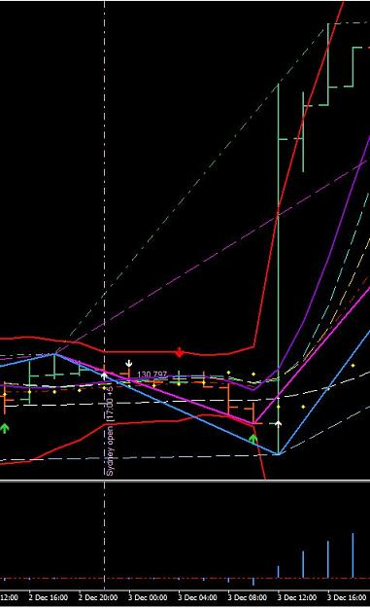
http://www.forexfactory.com/attachment.php?attachmentid=1844056&d=1454288607
If you noticed - the SAR did not repaint with the DB.
That's just it -- there is no repainting in consolidation.
..................................................................................................................................................................................
Quoting cfudge
{quote} Now PSAR has flipped on 2hr I have shorted back to Daily ROMAR area for 20 pips. Hopefully quick in and out. Yes Dove I know it is against SAR but we have room Long term SAR at high on daily
You trading against a 2 hour candle that is still moving and that flip of the parabolic is not set until the ending of that 2 hour candle. Which means - it still can be up at the ending.

01 Feb, 2016

You clean your trade up as soon as the SAR hits. Or else you will be losing your profit.
..................................................................................................................................................................................
Quoting woww
dear dove, it' the firsth time that i look the chart (H2) with PSAR between EMA and Smooth.. is it a particular aspect?
No its not; once the parabolic gets in between EMA and Smooth the trade is coming to an ending. Either a turn or a slider.
..................................................................................................................................................................................
Quoting dinkydau147
what are the 2 horizontal lines labelled b1 and s1 . what are they meant for ?
They are your MA signals: They operate closely to the nose level of an ADR indicator.
..................................................................................................................................................................................
Quoting Timo7
Hi, Dove, this is a great system, May I ask, how did you come up with this system? What is the background to it creating this? I'm sure a lot of us here would love to know. Thanks.
The story is something many would not understand. But without trying to insult those who do not believe I will try:
Every human being has a spirit. And if one believes in Jesus with all their heart; then has conquered many obstacles that stands in their way. My faith and belief is rooted so deep that nothing can destroy it. My own spirit is connected with the Holy Spirit in which He is our teacher and guidance in life. It was through He that the Paradox was created; which goes back to 2003.
..................................................................................................................................................................................
The SAR and Long Term swing indicators are your two resources for support and resistance in the Paradox. There are times the SAR will disappear after the Long term is connected. At least it seems so but the SAR is till there behind the Long Term Swing. It never disappears. Any time either one connects with a candle - the next objective is the opposite way. If the DB (Long Term Trend) is connected on Top of a candle then the next connection is on the Bottom of a candle somewhere down the line. And it is the very same for the SAR; and vice-versa. So, at this moment you had the DB on top of Fridays spike. Which means the next connection with the DB is on the bottom of a candle on the downside. This is also true with the SAR. It is connected on top of a candle and the next connection is with the bottom of a candle on the downside.
..................................................................................................................................................................................
Quoting rcbarlow
Basically, when you are Position (Swing) trading you can ignore everything except the Dodger Blue and Magenta SAR on the H1 and H2 and Daily Charts, correct?
That is pretty much in saying it. But eliminate the 1 hour chart. Just the 2 hour and Daily.
..................................................................................................................................................................................
Hesitation is a big stopper for traders. The fear factor. Because of fear you hesitate in pulling the trigger and there goes your trade and nothing you can do it about but letting emotions take control. And once emotions take over you on the path of destruction. Being patent is a virtue and once you see your trade - you hesitate. The fear just took over because your own is money on the line. That is something every trader has to conquer. And the only way to beat it is pulling the trigger.
..................................................................................................................................................................................
Quoting Cherry
{quote} Hi Dave, sorry if I confused you. I am using MT4. I was only questioning that you basically agreed said this morning in reply to rcbarlow when he asked: Basically, when you are Position (Swing) trading you can ignore everything except the Dodger Blue and Magenta SAR on the H1 and H2 and Daily Charts, correct? Yesterday you said: The Position is taken on the flip of the Fibo. The best entry is when the Parabolic had flipped also or the Parabolic is already in place with the Fibo flip. So my question is: That would mean we still require the...
When I position trade I us the 2 hour. Sometimes the 1 hour will give a position and it is short lived. The flip of the Fibo is your primary source of information for the position. Now - if the 2 hour is still in trend for the flip the consolidation is very well expected. Not always - but more consistent for consolidation. And that is why I said the Fibo flip with parabolic is the entry.
..................................................................................................................................................................................
To begin with traders - the 1 hour chart is a reference chart and the only reason it is included with the 2 hour is because the 1 hour was needed for the converter. originally I was not going to include the SAR_Swing or the SwingHighLow with the 1 hour because those two indicators do not belong with the 1 hour. But thinking about it I decided in cramming 6 week into a 2 week period may help those who have problems recognizing S/L. I can see I was wrong. The SAR_Swing and the SwingHighLow is to be deleted from your 1 hour chart. There is too much confusion with most of you. And they truly do not belong on the 1 hour.
To give an example of the SAR on the 2 hour chart; and by the way - the 2 hour is the only chart I trade - here is my entry and profit for my entry from the SAR.
At 2:20 PM (my time) this afternoon; I arrive back home and notice the SAR just being attached. I immediately pull the tiger for the short. and here the results with a 40/40 trade
Entry was at 131.969; and notice 1 trade for this date.
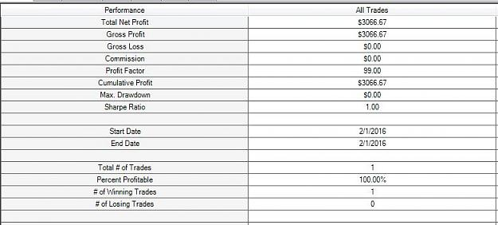
And here the Limit and Stop.
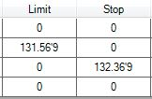

..................................................................................................................................................................................
Quoting rcbarlow
I did the same thing but mine is named Alert, but it does not work.
The sound folder is in your program folder (C) MetaTrader4 and you cannot change the name. The music you choose also has to be in wave (.wav) not MP3 or any other format.
..................................................................................................................................................................................

As you notice last night, early this morning, you had the Long Term (DB) attached without a label (rectangle price box); and then shot back up to the resistance Parabolic. And back down again for the DB and still without the label. The SAR is still holding for the down. If you go to page 40 and top of the page is a post for the reason.
Now - once the SAR attaches at the bottom WITH the DB it will go up as it will then have the label.

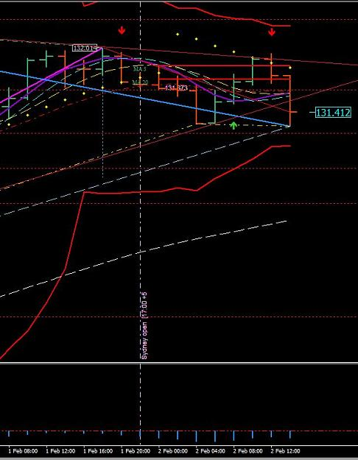
http://www.forexfactory.com/attachment.php?attachmentid=1845773&d=1454427669

..................................................................................................................................................................................
Quoting venividivici
{quote} I think I have a problem, my chart is not showing the same sar as yours. {image}
The reason is because you are with a broker that compromises their platforms.
..................................................................................................................................................................................
My platform is with FOREX.com which is a sister with Gain/Capitol. They do not compromise what-so-ever.
..................................................................................................................................................................................
Quoting venividivici
{quote} Could it be that I shut my computer between sessions? I think the template may be repainting everytime i turn on again, instead of leaving it open.
That too could be a possibility. I already told you what would happen if you do not let your computer running. This system runs entirely on data.

02 Feb, 2016

OK Traders: Lets get one thing straight. The SAR DOES NOT REPAINT. But what does repaint is the DB. You are trading on one scenario alone without seeking the big picture which is "in the moment". What have I said about the DB in TREND? It will move in trend from bar to bar. And what is the 1 and 2 hour charts in right now. TREND. You are in a consolidated trend which means (whichever trend of up or down); will not go that far. The SAR is attached with the DB and has no choice but to follow the rules. Just like last night. The SAR remain exactly where it was at from the top; and stayed there until it hit its target on the low side and attached with the DB. And when it did; what was the big picture?????
My friend Daniel had it right but no-one else did. The 4 horsemen on both charts was set for the race downstairs.
But; once the 1 hour had ended its trend then you start all over again. Those traders were in - you have your 40 stop. This is the reason for the 40 - from mistakes in not seeing the big picture.
And here is the big picture:
This 1 hour is showing nothing but a very strong trend down. But also the Fibo flip is holding back the trend from bar to bar. Until finally it bumped lower. Can anyone remember what I have posted about the bumps with a Fibo flip??????
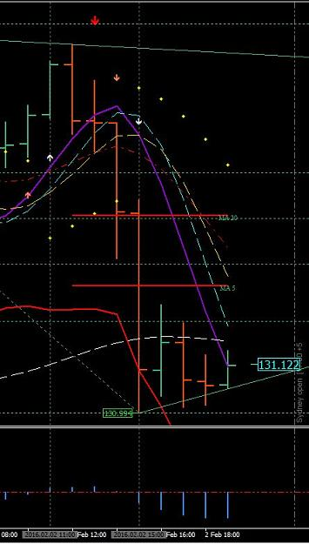
http://www.forexfactory.com/attachment.php?attachmentid=1846042&d=1454446672
..................................................................................................................................................................................
Quoting Pandakker
new high/low can be bumped up a few times
That is exactly right.
..................................................................................................................................................................................
A Fibo constitutes the VERY HIGH and the VERY LOW of a swing. The DB will display this with a Lime Green tag and the high will be tagged with the Magenta.
..................................................................................................................................................................................
Quoting whoareyou
{quote} Is there a way to be sure the rectangular boxes with the price in them at swing highs and lows will remain at that high or low and not move higher or lower? I, as well as many others here, were under the impression that when the zig line attached and a rectangle appeared with the price and that bar closed that that high or low was supposed to be concrete and not move. Could you clarify, please?
I never said that - I said once the Fibo flips with with the DB; either a new high or low that it can bump up a little higher - or lower - depending on the flip because of market pressure. But on the other hand - it cal also turn on the next candle and keep right on going. When I position trade on those new highs and lows I always use a 60 stop and never had one take me out with the E/J.
..................................................................................................................................................................................
Quoting Forex Lion
{quote} yes right, but it belong to the screen size, if I put it on my laptop, I see different fibo lines because of the size of the screen
One thing I have always recommended: NEVER use a laptop for trading.
..................................................................................................................................................................................
Traders - if you do not trade in the moment you will never see what is happening at that time. You have to see the WHOLE PICTURE before making any trade decisions. If you depend entirely on one thing the other will surely disrupt what you are depending on. And I don't care how you trade - it still remains the same. You have to see the big picture. This is one reason why traders fail is because they never see it.

I believe the in most part some of you have been focusing on position trading. I'm not discouraging anyone from position trading - but it is not consistent with intraday trading. Positioning is a total different way of trading.
Looking at this screen-shot of the 2 hour you have the SAR swinging for the low. And the Reason is because the DB is on top and the DB next target is the Low. From this point on with both the SAR and DB attached; the DB will be making the decisions for the new low. And ROMAR as support you can visually see various swings getting into that new low and once the DB had created its new low the Fibo will flip with a Lime Green price box
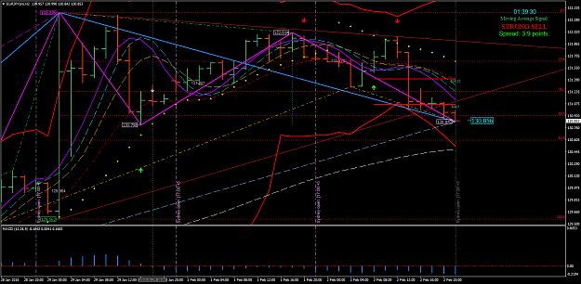
http://www.forexfactory.com/attachment.php?attachmentid=1846099&d=1454452412

You traders are anticipating in what is not there. You now have the 1 hour crossing EMA. which places the 1 hour ROMAR as Resistance. The 2 hour is in a strong downtrend. And with the two hour staying in trend will bring its ROMAR in position for crossing EMA. You have BOTH SAR and DB attached to the downtrend candle which means this could very well keep going from one bar to the next. The SAR now belongs to the DB. And will follow the rules with the DB. Your focus is on the 2 hour trend.

When you anticipate there is way too much confusion. You have to stay in the moment and not worry about what could happen but what WILL happen.

I'm going to try and explain SAR and DB again:
The SAR is the swings in between the high and low of the Fibo (Lime Green; low and Magenta; high). The DB is your long term swing in trend and will change the Fibo at the higher/high and/or lower/low. There are times the Fibo will flip on a Swing. But is still an entry with the flip.
The DB can and will mix with the SAR - as it is now. Once the DB and SAR are attached with the same bar then the DB has the control. In trend the DB will move from bar to bar in trend with the SAR following. And at times the DB is on top of the SAR where the SAR is not showing. And you will see this happening. But once the SAR breaks out from the DB it is then projecting its own swing once again.
Lest say the trend is down. The SAR leaves DB and reaches for the top of a candle. That is entry back into the DB trend and vice versa. And then reattaches with the DB.
Any questions?

Here is an example with the SAR and DB together with the SAR under the DB:
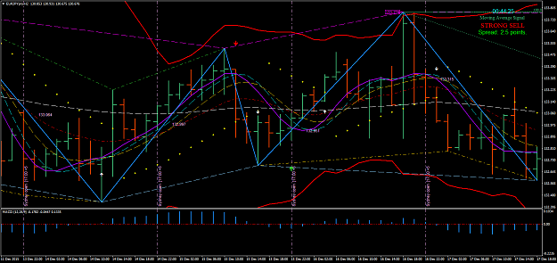
http://www.forexfactory.com/attachment.php?attachmentid=1846228&d=1454462220

Here a great example of the DB went from the top to the bottom to create a new swing going UP:
From the top was DB first attaching to the bottom - then on the way up in trend the SAR attached to the bottom of a candle from the top and placed you into the trend. And then reconnected with DB to end the Swing. But notice on both points for entry and exit of the SAR the next candle tried it best to get lower/low for the entry and higher/high after the exit. But could not do it.
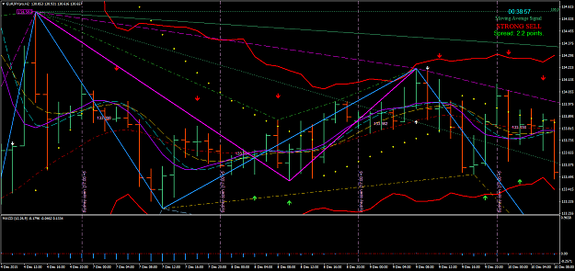
http://www.forexfactory.com/attachment.php?attachmentid=1846239&d=1454462901

As I have said - this is a very highly volatile pair. If you do not trade by the rules you will get burnt. The Daily ROMAR is resistance. The 1 hour ROMAR is resistance. And the 2 hour ROMAR is support but in the downtrend. White crossing Purple on the 2 hour will stop the downtrend for consolidating; but if Smooth does not cross then the trend is still down. Those are the rules. In consolidation the objective is taking a hit off resistance back into the trend - such as EMA as one trader had done to ROMAR. If you make up your own rules then the story is sad.
I made a post last night in regards with the Fibo of when it will flip. I stated it all depends on the 2 hour trend. It could flip at the 61.8 if the 2 hour White crosses to stop the trend for consolidation; or it will continue from bar to bar in creating a new lower/low. And as you can see it created a new lower/low and it is not finished yet. Smooth/EMA are still in the downtrend.
I have been trying to figure out why so many problems with traders MT4. After thinking about it; if you do not have your toolbars showing I want you to go to "View" - "Toolbars" and then click on "Charts".
You have an automatic scroll button and to the right another button which is shifting your chart from the right. BOTH of those buttons must be turned on. If not; then do so and see what happens from there.

Traders - when you make your plan be sure you take a very good look where the 2 hour EMA is located.
Some of you are reading EMA wrong in trend against ROMAR - which means - EMA crossing purple for the down; EMA is RESISTANCE and not support with ROMAR going up. Just like the 4 horsemen are resistance with the trend down, and vice-versa. EMA is your secondary trend according with the crossings of Purple.

03 Feb, 2016

Let's go back from the beginning with the UJ. We had consolidation with the Fibo up and gradually going up with the small swings. Then Friday we had the spike and changed the Fibo for the downtrend. So, for this week we had reached a new low with the EJ going through a swing up against the Fibo and then turned back into the trend to finish it up with a new low. The Fibo flipped and we once again heading for the High. That my friends is phenomenal in taking you from trend to trend.
And by the way - that is all on the 2 hour.
The problem is in taking time placing everything together. We were at the bottom and trades should be long from the bottom. Patience is everything.
..................................................................................................................................................................................
Quoting tonybrou
{quote} The Daily ROMAR is the key when the market will turn direction. Once it crosses Purple the game is over and time to be looking at the opposite direction for long term. ROMAR is also both Support and Resistance on all three charts. So the above only relates to the long term trend on the daily?
The Daily in not a trading chart but does follow the rules. The Daily is reference only for support and resistance. Right now the Daily is in the uptrend with the horsemen. ROMAR had crossed purple placing the Daily in consolidation because of the 2 hour ROMAR support. And because of this scenario with the Daily consolidating will surely give the Daily ROMAR a chance of crossing EMA to reverse the trend up. And that will give EUR the upper hand of taking off with the market; especially with the 2 hour having the powerhouse with ROMAR support.
I hope that answers your question.
..................................................................................................................................................................................
Traders - I suggest very strongly to place more value on the 2 hour chart then the 1 hour.
To be honest - I do not trade the 1 hour. The 2 hour is the only chart I trade. During training I give reference with the 1 hour in seeing a trade with the 2 hour. But to answer your question is no I would not have. The entry was the open above EMA with the Smooth crossing.
..................................................................................................................................................................................
Right now I am on hold for an entry because of the 1 hour ROMAR. After ROMAR crosses EMA then I would be looking for a long trade but - I be sleeping by then.

04 Feb, 2016

Traders - I have explained very clearly from the beginning on setting up your MT4 with the spreads of vertically and horizontally. I had given you the templates with the correct spreads. I also stated you change anything then you will have problems. So don't come crying when you make changes.
The Paradox Divergence is not standard either. They are the Green dash-dot lines and the Gold dash-dot lines. They represent the higher/high with the Green and lower/low with the Gold.
And that works in both Swings and Trends.
..................................................................................................................................................................................
Quoting rcbarlow
Maybe I missed something. This is the first I have heard about Divergence in this system.
I mention it in the beginning but haven't express much on it because of the time table. Most traders do not have any experience with divergence and the paradox is more complicated then the standard.
..................................................................................................................................................................................
Quoting rcbarlow
Yes, I read that at the beginning to identify the lines, but nothing on how to use them. Could you please elaborate of this?
I really don't have that kind of time - in fact, I have to leave very shortly and be back about 17:00. But if you are familiar with divergence then if you study the Paradox divergence you will get it.
..................................................................................................................................................................................
Quoting arya.aryaee
Hello Dear Dove! what is usage of MA5,MA20 lines ? thankyou
When a trader uses an ADR indicator (Average Day Range) it also has what is known as the ADN (Average Day Noise) which most traders have no knowledge of. On the Paradox this average day noise is displayed at the very beginning of the 17:00 EST Daily candle. This is one reason you reboot your platform after 17:00: If you reboot then; and reboot again on closing your platform - then the ADN has changed position from the previous data.
The Average Day Noise is consider the noise of the traders trying to position for a trade with the opening Daily Candle. And the ADN indicator lines never moves but remain as they are from bar to bar (accept squeezing towards one another) as the market is moving.
So the MA is the ADN of the ADR. In between those lines is Weak Sales or Weak Buys depending on trend at opening. Strong buys are above the MA 20 and Strong sales are below the MA 5. That is what the MA means and what it is for.
..................................................................................................................................................................................
Quoting diamonddbw
This is a picture of all four types of divergence I'm aware of. Not sure if Paradox Divergence standards are the same. Will wait to hear from Dove. {image}
Your examples of the 4 divergence are correct as for the standards. The Paradox is closely related except they are set for in the moment and not long term such as the standards. Once you have learned to use them they can help with your reversals.

There is one thing I like to touch on with the word most traders use and that word is - ”Repainting”; which has been used many times with this system and what does repainting mean? It means again, and again, and again.
There is only ONE indicator with this system that repaints; and that is the Long Term Trend (DB). And the reason is because it is a trend indicator and nothing more. So, it does repaint from bar to bar in trend. Even when the signals go off – they do not repaint. They go off once and that is it; and they remain until the next opposite signal; and that too remains until the next opposite signal. So, the bottom line there are no repainting’s with the Paradox except for the DB.
As regards with the SAR: It is pretty much set in stone once the SAR has attached itself with a candle that had ended; and stands alone without the DB attached with it. There has been a few times through the years I have witness the market trying to retest the SAR; especially in high volatility and bump the SAR a few 10th of a pip and reset the SAR (without the DB) with that bump. But that is it.
“IF” you trade this system by the Paradox rules then you will become 100% on your trades. The “RULES” are set in stone. You break one of the rules then you will be burnt. And I cannot make it any clearer than that. We already have traders’ 90% profit with this system. The reason is because of patience and abiding with the rules. So take their example and learn from them.

Let me put the 1 hour into perspective. If you made an entry with the I hour and it is not on the same 2 hour bar. What do have?
You have an offset with ending candles. If you go in1 hour prior with the 2 hour then; the 1 hour will end and a new 2 hour begins. If you get in the 1 hour later with the 2 hour; you have the 1 hour ending and the 2 hour still running. So you must keep in mind with the offset of the two charts.

Within these two weeks of training you have the variables for the Paradox:
1 – Support and Resistance as the market is moving.
2 – How swings are developed according to Support and Resistance.
3 – The importance of the Fibo according with the 61.8; and how the Fibo is flipped for the trends.
4 – Using the 4 horsemen in the swings.
5 – Entries and Exits according with the 4 variables above.
I have dictated the rules for all the variables and how to apply the rules separately; and in conjunction with each other. As I have said – this is a 6 month program and will take time for studying. There are some that will catch on quickly and others will take time. So, if your desire is to become a full time trader constantly in profit; then take the time to study, and study, and study.

Traders - do not ever disregard the 2 hour ROMAR for either support or resistance.
I trade the 2 hour bar. If I see the an entry on the 2 hour then I reference the 1 hour to see if the 1 hour is in consistent with the 2. If they are then I will take an entry off support going up on either chart or - down off resistance on either chart (depending on trend). BUT again; the entry has be within the last 10-15 minutes of ending the 2 hour candle. If too early could cost me the retrace (drawback) of the entry. In other words - The 2 or 1 could hit either support/resistance and keep going lower/low or higher/high with the entry and leave me in the hole instead of B/E. Most times I will wait for the next 2 hour open bar.
..................................................................................................................................................................................
Quoting tonybrou
Hi Dove There is some medium important data coming out on friday for Japan would you recommend closing positions?
The NFP effects all the major pairs. Like I have said - you close your trades at least 5 minutes before the announcement. Either in profit or in a lost.
..................................................................................................................................................................................

Well, my fellow traders and friends;
It is now the end of my promise for two weeks of training. In these two weeks of training I have given you every detail and scenarios in how to trade this system. I have given you all the rules for trading this system; and no-where you will find any of my posting in contradiction with the rules. They are set in stone.
Some of you will, and most of you won’t be trading this system. And the reason is because of those who “will not”; cannot see the benefits in learning the basics. Another reason is because of “old school thinking”.
There have already been successful traders with this system in the last two weeks; and some are no longer on this forum. They are gone because their search for the so call “Holy Grail” traders uses; is now in their hands.
To be a master with anything you must gain knowledge. And learning is the way to become a master. That is how you gain understanding; by learning. You have been given an open book of a system that will help bring your dreams into reality. But as individuals being successful will entirely depend upon your learning skills.
Skills of learning are like building a house. The structure of the foundation is the very basic if the house will say on its foundation or come tumbling down. If the foundation is not study correctly before building; then how can you even understand the fundamentals of building a home? It is the same with trading. The foundation comes before anything else; and you build from there.
There were several traders on this thread looking to be spoon fed with entries and how to this and how to do that; even after they were given the answers. These traders are your failures because they did not want to take their precious time in learning. They wanted something free (in which they did received for free); but did not realize what they had received; was their destiny into prosperity. This system is not for everyone – and that is for sure.
I suggest you traders stay together on this thread and help one another. Minds working together have a higher percentage of being successful. Those who get discourage then walk away and give yourself time to recoup; and then come back and reorganize your thoughts.
For those who are still trading with the “old school of thinking” with this system. Then I suggest in walking out of the dark and see things in a different light. Trading has changed and nothing is never what it “was”.
Trading “in the moment” is not a new concept. It has always been in the moment for trading. The market moves constantly in creating its own support and resistance from bar to bar. And nothing will ever change that concept. The Market has always been about support and resistance.
Just realize you have a very powerful system that will take you in and out of supports and resistances. All you need to do is learn how to trade in both directions. Being bias will only destroy you in being a true trader. It destroys the true concept of what is truth in trading; and that is both support and resistance also known as the Paradox. They are opposites of one another but actually true and possible to trade.
In closing: Iwant to thank all those who jumped in to help your follow traders with technical and trading problems. You have no idea how appreciative I was in what you have done for the others. I especially want to thank TradeAlot for his gracious and selflessness gesture in formatting word.doc on the daily lessons as a manual. His work will help everyone. Thank you Sir, for your kindness and the great heart you have.
Try to remember I have given you a system in two weeks that takes 6 months to learn You must go through the training over and over again; until it becomes second nature. TradeAlot’s work will be a great benefit for each of you with your education in learning this system.
At this time I have one request: Please, do not PM or email a request of extra training or one on one. If you do; I will totally disregard your request without answering you. After I have logged off FF today; I will officially no-longer be a Forex trainer. Thank you.
Dana
The Dove - Forex Trainer
20 Feb, 2016

When trading the Paradox your virtual mind is your enemy. The reason is because of the way you had been train to think since childhood. Your mind is adventurous, always seeking new things. And the world is a wide open space for your mind to travel in with many things blocking your way.

The Paradox was built to establish faith and belief. It is a concept that the virtual mind cannot established within itself. Believing and having faith is not the way of your virtual mind. So the mind must analyze a concept in order to understand it. But here is the problem; having faith and believing is not seen within the virtual mind but only through your own spirit can it be established. And with the mind trying to analyze this very concept; many things become blurring and reality does not set in.

Trying to analyzing something that has already been established as IS, will only defeat the fortitude of your faith and belief. So in order to defeat the market you first must defeat the analytical side of your mind. And this is why so many cannot wrap their minds around the Paradox.

Trying to analyze something that has already been established is like beating your head up against a stone wall. It is getting you no-where but only frustrations after frustrations. In other words all entries and exits had already been established before they even appear on your charts. But without believing and without faith: you will miss it because your virtual mind is in a state of roaming through space that is filled with nothing but pure garbage.

The analytical mind is powerless when it comes to what has already been established. Seeking the reasons why is like your inner Self as unknown territory. You do not really know who you are from the inside out. You know who you are from the outside in. You know the outer reactive you, but not the inner proactive you. You know the frightened you far better than the courageous you. You know the part of you who clings to the world as you want it to be far better than the inner you, who understands that the world is in constant flux and that you must learn to flow with the change and flux that is the nature of life. Learning to let go, not once, but again and again, is the path of learning to live in harmony with the laws and ways of life instead of living in opposition to life.

So, in order to beat this constant flux lies within faith and believing in something that is far greater then yourself. The Paradox has already been established and there is nothing that your analytical mind can do to change this very fact; just as it is with your inner-self at the very moment of conception. And being fair with the constant fluxes of life we have our own intellect that allows us to make choices. And what choices we make in life will determine our destiny.

Connecting with the spirit inside you is not something that happens once and for all. It is a slow and gradual process, in which you connect, disconnect, reconnect... Gradually the focus of your consciousness moves from duality to oneness. It re-orients itself, finding that eventually it is drawn to silence rather than to thoughts and emotions. By silence I mean being fully centered and present, in a state of non-judgmental awareness in the moment.

There are no fixed methods or means to get there. The key to connecting with your own Spirit is not to follow some discipline (like meditating, or fasting etc.), but to really understand understand that it is silence that brings you home, not your thoughts or emotions.

This understanding grows slowly as you are increasingly aware of the mechanism of your thoughts and emotions. You let go of old habits and open up to the new reality of heart based consciousness. Ego based consciousness inside you withers and slowly dies. And once that happens; you are then on the threshold of the moment. Your spirit then can see what is happening without all the garbage blocking your way to freedom.

One thing you have to always remember: the 60 is the beginning (Alpha) and the 120 is the ending (Omega). In short term it means everything begins on the 60 and everything ends on the 120. So all your trade entries begin with the 60 and your exits are with the 120.

The 120 chart has 12 bars during a 24 hour period. Does this mean the trend will change on the 120 during those 12 bars? That will entirely depend on what your Daily Trading Plan is saying within the 2 hour chart. You cannot trade without a trading plan. Without a trading plan you have no idea what is happening within the market. You HAVE TO BE aware of the market before trading the market. And a trading plan gives you that awareness.

Most of you are making up your own rules; trying to detail a trend and/or consolidation. Bottom line old habits take over and you have no idea what you are doing. Instead of trading in the moment your focus is on past history of what was and not what is. And all it takes is White crossing Purple on any of the charts that are in trend; and you are automatically in consolidation. And with the White crossing Purple can place you in a consolidated slider for the continuance of the trend; or a reversal on a new swing.

There is one; possibly two traders have got it for sure. They are seeing what is happening and not trying to analyze what is happening. And that my friends are what makes the difference of becoming a great trader; and/or a loser. It is the spirit within these two traders that makes the difference of becoming greater today than they were yesterday. If they can do it; then so can you. There is no limitation on what your spirit can do. All you need to do is connect with your own spirit; then there are no limits in what you can do with every realm of your life.

Trading the Forex is totally about support, resistance, and trend; three variables with a continuance of swings. And each swing has a support, resistance, and a trend. Now take a few moments and re-read what I had just said.

Now wrap your mind around this statement:

Whoever trusts in his own mind is a fool, but he who walks in wisdom will be delivered.

And what is the wisdom for trading? The answer is the Three Variables. Those variables are the total answer and source for trading. If you try to create something outside of Support, Resistance, and Trend; then you should be looking for something else to justify your ego. There is nothing outside of those three variables when it comes to trading. Even in consolidation there is a support, a resistance, and a trend.

I have stated this is a 6 month progress. There are some have already moved on because they no longer need to be here as they had gain understanding with wisdom; and trading live accounts successfully with the Paradox. The 6 month processes are for those who need to learn in stepping out of their comfort zone; and learn to trade outside of the box. And it will take time provided you are willing to step out of the box. For those who are in love with their own ego, and want to ridicule others for wanting to help their fellow traders; are the losers. There are more losers then winners because the losers heart is never in the right place.
For those who want to learn then stay true with your quest. Dont let those who have no wisdom try to modify or steal your dreams. Just always keep in mind that patience is a virtue and must be acquired in order to be successful.

And even though I am not showing online does not mean I am not here.
..................................................................................................................................................................................
Quoting snfx
Well isn't it strange that suddenly, namely out of nowhere, we have this campaign of "naysayers"? Isn't it strange that all they could say is that they are all very profitable but just came, for our own sake, to rescue us from falls knowledge that some guy tried to hoax us spending hours in writing his hoax system and hoax trades? Isn't it strange that you will rarely find honest broker and that most of them made profit if you lose? Would these gangster brokers like to see Joe taking 40 pips every day? Hey "naysayers" You can try to discourage as...
I have no idea of who you are. You came out of no-where! But I am very impress with your success with the Paradox. And I want to thank you for encouragement you have given to the others with your trading. You are one of few that had done it so quickly. Congratulations and thank you again.
..................................................................................................................................................................................
As you can see both normdiploom and mine are pretty much the same. The only difference is taking the Fibo into consideration of being oversold. But that does not mean it would not go lower/low -- the only thing that can stop this from reversing is the 2 hour EMA holding resistance.
Without these trading plans the 2 hour EMA would NOT had been recognized as the stopper for a reversal. Also - you would not had been able to see an entry on the conditions that is happening in the market.
Apparently everyone understands the meaning of creating a trading plan as there are no questions. So - what I like to see is everyone posting a trading plan everyday as to be sure you do understand in how to create one.
..................................................................................................................................................................................
Quoting lkh81
Hi, Would anyone be able to guide me on this? I've been reading this thread since last Monday. I'm new to technical indicators(i've never used one to trade actually). And i thought MA = MACD until i saw there is actually 2 red horizontal bold lines that shows MA 5, MA 20. Initially thought it was some fibo settings(i didnt know about fibo also). How does one make use of this?entry below the boundary for buy trade? Sorry i am too nub on this My last read was on page 34, so if it was discussed in more detail after that, i can read that post too. Additionally...
The MA signal is for the trends (Coral Arrows) and they can go off during a consolidated period and/or sideways. And they can give a false signal when consolidating. If you want to delete the MA signals then do so. Like I said - they are mostly for the trends.
The MA 5 and the MA 20 cannot be deleted - they are part of the data. And they have been explained somewhere on this thread. So continue reading and you will come across it.
..................................................................................................................................................................................
Quoting lkh81
also another point, Green Arrows = market crossing EMA The first green arrow on the left of the screenshot doesnt appear to cross the EMA. (or did i took down the wrong info?) {image}
All it has to do is touch EMA.
..................................................................................................................................................................................
Quoting Masik
Sir Dove I have a question on your trading plan. Why you are considering going long if all Romar are resistance on all three charts and the trend is down? I'm supposing that I could trade both ways only in consolidation.
OK -- you are not paying attention with the postings. My question would be: What is the First indication of a consolidation?
..................................................................................................................................................................................
Quoting lkh81
{quote} erm in the screenshot, it didnt touch the EMA. Did my settings go wrong? it downloaded the forex.com demo account which snfx says is 100% accurate. and followed the instructions accordingly. I on my PC at 17:35est which is 1hr 30 mins ago. did i do anything wrong ? {image}
Take my word for it - it was touched - may not show with the candle; but it was there and gave the signal. That is for both the up and down Arrows. In other words - you was alerted before it even happened.
..................................................................................................................................................................................
Quoting Masik
{quote} Purple White crossing?
That is correct and it is on any of the charts. Once White crosses Purple on any of the three charts you are AUTOMATICALLY in consolidation and you can trade both ways.
..................................................................................................................................................................................
Quoting crobbins
{quote} the last part says: If a slider is in the makings then the 2 hour EMA will hold support. Im a little confused because it seems that if there was a slider then the 2 hour EMA would continue to hold as Resistance not support
You are correct and made the correction - but I am sure you know exactly what I meant.
..................................................................................................................................................................................
Quoting dove_alliance
Entry: With all three charts being oversold with the Fibo at 125.006 for a new low and the 1 hour showing a possible flip of the swing; is giving a picture of 2 elements.
1. A slider on the 1 hour for the continuance of the downtrend.
2. An open candle above the 2 hour Smooth at the Purple crossing for an entry going long with EMA holding resistance.
If a slider is in the makings then the 2 hour EMA will hold resistance. So taking these two elements into consideration the best entry would be off the 2 hour EMA for the short without the 2 hour...
Take a very close look at this Picture and what do you see?
You see the Open at EMA with the Smooth sliding with the White and no crossing of the White/Smooth. And because of the Smooth not crossing White a short entry was taken. You also had the 23.6 holding resistance with EMA. I had also stated that lower/low was consistence with a slider on the Fibo.
I gave you the entry but ...... no more needs to be said.

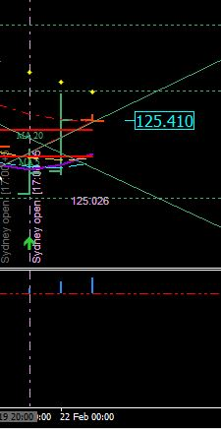
http://www.forexfactory.com/attachment.php?attachmentid=1862330&stc=1&d=1456149586

Traders - when you break the rules you will only defeat yourself. That also means trying to trade other timeframes besides the 1 and 2 hour. The Paradox is not set up for any other timeframes accept the Daily, the 2 hour, and the 1 hour.
..................................................................................................................................................................................
Quoting snfx
Wow You all did good job, I had two position both short on UJ so -80 for today.
This is an example of breaking the rules. Two trades in being greedy had cost you -80 instead of -40.
..................................................................................................................................................................................
Quoting xpie
{quote} Is that a general rule, that white has to cross smooth for a trade to be taken?
Only when you are counter-trading against ROMAR. Then you need the White/Smooth crossings at Purple.
..................................................................................................................................................................................
Quoting goldtime
{quote} Mr. Dana, would you like to explain the meaning of : lower/low was consistence with a slider on the Fibo. thank you
At opening yesterday you had the Fibo low at 125.006 on three charts. The power of the down was still in place on the daily chart. This means the Fibo was consistence on all three charts for a lower/low with a slider for continuance of the downtrend.
..................................................................................................................................................................................
I have been getting a lot of PM's requesting one on one training. As I have stated - if I receive such request I will ignore your request. My days of training are over. I am here to finish up what training is needed and I will be in and out periodically to help with more training. I have a ministry and that comes before all else. I am sure everyone understands that.

One thing I want everyone pay attention too:

I had seen what was happening on my Daily Trading Plan. I had posted my plan so everyone could see what I was seeing; before it even happened. Now - without my plan I would had missed it totally and probably done what most of you had done: Lose a trade.

The bottom line traders - you cannot trade without a plan. I am good at what I do - but only because of creating a trading plan and trading in the moment. That is the only way of robbing the banks and doing it legally.
..................................................................................................................................................................................
Quoting JMaurice
{quote} Thank you for the response, I very much appreciate it. The picture you posted in the last page didn't include the next bar as the chart I posted did. White/Smooth have crossed in the picture I posted, and definitely had crossed by the next bar. I'm not trying to be difficult and I understand losses can and will happen, but just trying to clarify if there was some other reason to avoid going long. {image}
You are not understanding the concept. Every trade is in the moment. What is being said in the moment is truth. Not the next bar or the previous bar. But what the actual bar is saying in the moment; and that moment was on my trading plan. Now - do you see the big picture?
..................................................................................................................................................................................
Quoting Sicarius
{quote} I'm assuming hes saying he only trades the first 3 candles of the Sydney open but I'm not sure lol.
No - I wasn't trading at all at opening. I was creating my trading plan for my trade.
If I was trading yesterday at opening I would had gone long with the Open Candle showing the Gap for 40 pips.
..................................................................................................................................................................................

Quoting JMaurice
{quote}However, if a trader were to miss that moment, a trader may have viewed the market at the next open 2Hr bar, which opened above EMA and white and smooth had crossed. I obviously do not fully understand yet, but appreciate your help and will continue to study. Thank you.
However is key word:
What I do not understand is why would a trader open their charts and see a potential entry and then pulls the trigger?
My entry short was totally based on a trading plan and not on whim. I repeat it over and over: You cannot trade without a trading plan. If you do then danger is in the horizon.
..................................................................................................................................................................................
Quoting rcbarlow
Dana, When you get time, would you please post a H2 chart showing your swing trade? My problem is when both the SAR and DB reach a bottom and the FIBO flips, it may go up a couple of bars, then iti continues down even though the fibo is green. I have seen it go down 173 pips and the fibo still remains green and it is still going down with a green fibo Thanks..
And it will do so either direction in a trend. Until the trend ends it will stay green and continue down. There hasn't been a swing on the 2 hour since the high at 127.384. EMA is keeping a tight hold of resistance and haven't let go yet.
..................................................................................................................................................................................
Quoting rcbarlow
I know that. But for Swing trading, I thought it might be something else, since Purple can cross EMA several times in shallow swings while Fibo is still the same color.
RC - you have been looking for short cuts and they are not there. The only time EMA will cut in and out of the 2 hour Purple is in consolidation. And right now the 2 hour along with the Daily are in trend and not consolidation. The Fibo is at the "0" line in trend and will remain at "0" until the trend reverses into a swing with the 2 hour. Stay off that 1 hour and you may get somewhere.
..................................................................................................................................................................................
Quoting JMaurice
{quote} Thank you again for the response; I guess I need more time trying to understand this and appreciate your patience. In that moment, the market had fulfilled conditions for the short entry ('off the 2 hour EMA for the short without the 2 hour Smooth crossing [of White and Purple]') as detailed in your trading plan. Hypothetically, for the sake of understanding, if the market had taken longer to reach the EMA, White may have crossed Smooth by the time the market reached the EMA, and then the close above the EMA would have satisfied the trading...
Hypothetically - that is true. That is why my trading plans always have an entry for the short and an entry for the long. I am never bias. But the plan has to be constructed in such away that hypothetically both short and long are configured on the same 2 hour bar.
Just as yesterdays plan the 2 hour EMA was the root of the plan in being the only resistance from stopping the reversal. And being both ROMAR and EMA having the power as stoppers in the market; you have to visually see this as you are creating the trading plan. And by seeing the 2 hour Purple sliding with Smooth not crossing White; but to hold EMA in power, I was able to take the trade short. If Smooth had crossed White then Purple would had allowed the crossing for the EMA crossing going long. And all this was happening on the same 2 hour bar. And that my friend is trading in the moment with just one 2 hour bar. In other words - you have 2 hours to make a decision.
..................................................................................................................................................................................
Quoting velox
{quote} Thank you so much Dana for continuing to help us here. I am also a culprit of sending you PMs about one on one training but totally understand your decision. When you say you have 2 hours to make a decision, does that mean we will be taking the trade during the 2 hour window (i.e when the 2 hour bar is being formed) and not just at the completion of 2 hour bar. TIA
The 2 hour bar is your "in the moment" bar. You create your plan and you pretty much going to know your entry - OFF THE 2 HOUR BAR - using the 1 hour as reference. From the creation of your plan you check the 2 hour bar every two hours about 5 minutes before the next bar. At that point you will see what is happening towards the ending of that bar. If you do not see anything indicating your entry - then you check the ending of your next 2 hour bar. And you continue to check until you see your entry being created in pulling the trigger at the right moment.
..................................................................................................................................................................................
Quoting xpie
{quote} Just to make this clear as I think it is important: with the moment you mean the 2 hour candle that touches the ema first. When the price stays there for several bars the following crosses of smooth white etc dont matter anymore. Do I get that right ?
No - that is not what I mean because every trading plan is different from day to day. And you will not understand until you start learning in how to create a trading plan and able to see what is happening in creating the plan from chart to chart. When your entry comes up you pull the trigger and matters not what had happened or is going to happen and the reason is because the Paradox had already set up the entry.
Price has nothing to do with it. The set up has everything to do with it.
..................................................................................................................................................................................
Quoting velox
{quote} Thank you. I think this clarifies it for me. To paraphrase, just so you can correct me if my understanding is wrong. You make your plan at the beginning of the day (5pm NY time) and then you check for an entry at close to the end of 2 hour bar. If conditions are met, you take your trade. So most of your trades will be initiated at the end of 2 hour bar (i.e. 7pm nyc, 9pm etc).
That is correct – 90% of my trades are within a 6 hour or less period from the 17:00 EST 2 hour bar. Most of them are less than 4 hours. I do not spend all day at the computer in trading. I create my plan and when the entry shows I pull the trigger for 40 and I am done until the next day.

As an example - my daily plan for today had called for the hit on the 2 hour Smooth going short which happened on the opening 19:00 EST candle.
..................................................................................................................................................................................
Quoting Sielik
{quote} Does it happened to you that the entry not shows up and then you do not trade the whole day?
No - when I make a plan the set up shows up. Always. If I set at the computer looking for a trade then yes - I can and have, lose a trade for the day.
..................................................................................................................................................................................
Quoting xpie
{quote} How do you decide what to choose as a trigger ? For example why did you choose smooth and not EMA as your trigger for today ?
Because Smooth was the first resistance for the trade.
..................................................................................................................................................................................
Just like last night - the 2 hour EMA was the only Resistance for a trade going short. And the set up for the short was showing with the 2 hour Smooth in not crossing White. And it doesn't matter if the crossing happened 2 hours, or 4 hours later; and the reason is because Purple was not in line for the EMA crossing without the Smooth/White crossing on the same bar of the entry. This meant that EMA would slide over Purple for the continuance of the downtrend. And that my friends is looking into the future.
Now - everyone get your mind wrapped around that and study in how EMA slid right over Purple without crossing.
..................................................................................................................................................................................

Quoting mav3n
{quote} From my understanding, purple and white are also resistant, but you defined Smooth as first resistance because it is above the candle. Do i think correctly Dove? Thanks
On the Opening Bar at 17:00 was going up heading for Smooth. All I had to do was wait on the next 2 hour opening for my entry. Very simple - and reason is because I had seen it in creating my plan.
..................................................................................................................................................................................
Quoting JMaurice
{quote} In a 'trend', will you always use the first resistance up for a short (in downtrend) and the first support down for a long (in uptrend)? (Provided of course all conditions are still maintained as presented in the trading plan once the market reaches the support or resistance.) Thank you for all your answers the past couple days, a number of questions I had are no longer questions.
In a trend and looking for an entry there are two scenarios - In an uptrend the 1 hour hit off EMA is the entry going into the uptrend. On a downtrend - the hit on the 1 hour Smooth is the entry.
..................................................................................................................................................................................
Quoting JMaurice
{quote} I'm sorry, in a downtrend the hit on the "1 Hour Smooth" or do you mean 2 Hour Smooth?
We are talking trend and not consolidation. In trend it is the 1 hour Smooth. In a downtrend most hits are off the 2 hour white and most times 2 hour will not even get that far on retraces.
..................................................................................................................................................................................
Quoting JMaurice
{quote} Thank you again. I confused myself because we were just discussing your entry at 2-HR Smooth.
At opening you had the 1 hour in consolidation with the White/Purple crossing and the 1 hour Smooth in a slider for the continuance of the downtrend. That left open the 2 hour Smooth for the entry on the next 2 hour candle.
..................................................................................................................................................................................
Everything I am posting is on my Daily Trading Plan. I am really hoping you traders are beginning to realize the importance of a trading plan. Most of you are seeing things that are not even there is because you are not looking at the moment.

23 Feb 2016

What is FEAR?
False Evidence Appearing Real
And what does that mean – it means a “Lie”. Fear is the greatest emotion in a human being. It destroys the convections of one’s own thinking. All it takes is someone to post, or say something against your convection; and within 30 seconds the seed that had been planted, will fully bloom. And then fear had set in and taken control of your emotions.
This is very true when you have multiple postings on a subject that no one really understands. You have those who think they know the answer and state a fact – which in reality is a lie. And then you have those who will post an answer with another question attached. Then there are those who have the answer but are afraid of their own conviction and say nothing.
Being in the background is a safe haven for those in fear. In reality it is a vicious circle of bouncing off one spectrum to the other. Fear comes in many variables: Afraid of losing something; afraid of being wrong; afraid of not having the right stuff to succeed; afraid of setting goals; but mostly – afraid of your own convictions.
The meaning of Conviction:
: a strong belief or opinion
: the feeling of being sure that you believe or say is true.
And the opinion of others could very well steal your convictions.
So my question is: What are you afraid of? The answer is a fear of stepping out of your comfort zone. Going beyond what you are already comfortable with and afraid of losing on something that you already know is true.
Think about that traders and I will see you tomorrow.
..................................................................................................................................................................................
I made another trade last night to give an example of trading in trend:
I waited on the 1 hour to close for the entry off the 1 hour Smooth because of the volatile candle. On opening of the next candle I took entry off the 1 hour Smooth.
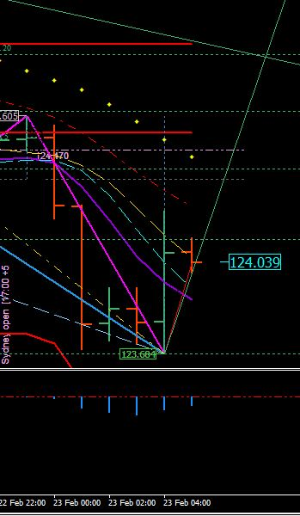
http://www.forexfactory.com/attachment.php?attachmentid=1863361&stc=1&d=1456243369

Quoting chonchy
{quote} ...That maybe my fault Sir. I encourage them to wait for you to open a new training camp like you usually do, when the trolls make you go private, but I see also that you have lay out everything for them very neatly and you are here to dissipate any dough they may have about the system, I think the system is flawless, like all yours before and the probe is that some of them already got it almost to perfection, carry on my friend and again congratulations for a job well done, again thanks for all.....and I'm sorry if I missguided them.........
No Carlos -- it was not your fault. In my summary I had stated the same thing as I had posted above. So they already knew before you had said anything. But on the other hand - thank you for being there. God bless you.

Take note of the Arrow pointing up on the bar that the candle hit White and retraced off White:
You always have to remember that the 4 horsemen are both support and resistance. What this means on this particular bar the candle did not get below Purple but held up on support of White and is now going into consolidation. And at 17:00 EST your trading plans will be different. The way I see it will be pretty much be the same set up as it was a couple days ago with EMA having the power. So I'm just giving you guys heads-up.
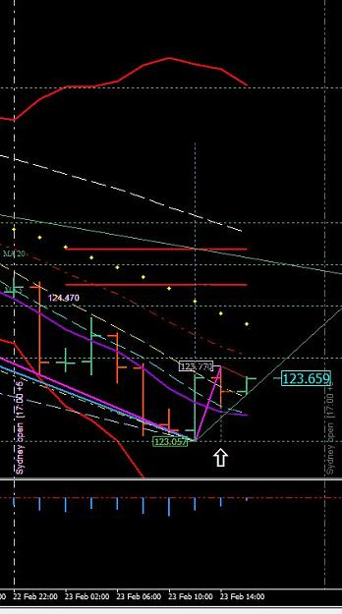
http://www.forexfactory.com/attachment.php?attachmentid=1863406&stc=1&thumb=1&d=1456246193
..................................................................................................................................................................................
Quoting Contrax
{quote} Hello Master. Everytime that i see the Market, i always do a "New Daily Plan". I mean, when new day appear i restart the MT4 and i let it open 23:59hrs. And in that time i make my first Daily Plan, but every 2 hours or when i have time to see the Charts before i entry, i make a new Daily Plan... I mean i like to make a completly Analisys of the moment H1 H2 D1 in "that moment". So if i check, for example right now my charts. I made right now a new Plan for my entry and somethings like that. I dont know if im doing the right thing or not,...
- everyone is different in making trading plans. If it works for you then that is good.
..................................................................................................................................................................................
SirViver Trading plan

Daily at lower low than yesterday.
Romar is resistance
Parabolic resistance
EMA is resistance
Close of daily bar near session low, and entire bar is below purple. 4 horseman running downhill.

2 Hour
Romar is resistance
Parabolic is resistance
EMA is resistance
Low of last bar was session low, but the bar closed as an up bar, just touching purple.
4 horseman in line running downhill.

1 Hour
Romar is resistance
Parabolic is resistance
EMA is resistance.
We are in downtrend. 23rd bar was pinbar, closing bar is up. closing bar thru purple, white, & smooth.
Purple and white running parallel and white is trying to cross purple.
I plan to trade in the moment and watch to see if the 2 hr white and smooth will cross purple up & jump in with short if market bounces off EMA and turns down again, or watch to see if market goes thru the ema with possible long entry if it hits parabolic on other side & parabolics flip. I plan to take my time with an ideal entry, and not rush in just to be in a trade.

OK – let’s take a look at SirViver trading plan; and I am not criticizing his plan but only referencing his visuals:

He is looking for a short off the 2 EMA and a long with open above the 2 hour EMA. But there is a problem with both trades as he is looking on with the 2 hour.

1 – The Daily is very strong with the downtrend.

2 – The 2 hour is also very strong with the 4 horsemen and will hold resistance for the continuance of the downtrend.

3 – The 1 hour EMA is also strong in the downtrend along with Parabolic’s heavy in holding resistance. At the time of his trading plan both White and Smooth are sliding for the continuance of the downtrend.

So, in his mind he will wait for the 2 hour EMA in HOPES of being right. And in this waiting mode he had been subjective in waiting instead of being objective with the resistance.

At the time of his plan there was no indication of either the 2 hour or Daily going into a swing change.

Creating a trading plan you need to be objective with both support and resistance. The first indication of change in swings is with the 1 hour Parabolic flip; and the verification is with 2 hour EMA crossing Purple.

So the objective of creating a trading plan is never be intimidated in hoping what will happen but be objective in what will happen.

And I pray SirViver you didn’t mind me in using your plan so others can learn from your plan.
..................................................................................................................................................................................
Quoting Ygr
Thank you for your kindness Dove. I am eager to learn your system however what will happen if they switch to mt5? It will still work?
I have no idea why everyone is worried about the MT5. The MT5 has a long, long ways of ever being right. Right now the MT5 sucks and a lot of changes has to be made before they even think of devolving the MT4; in which will never happen because of the world wide usage of the MT4.
..................................................................................................................................................................................
Quoting Masik
{quote} Maybe I was wrong but I guess that in consolidation 2h chart give the trend direction. In this case we have smooth above purple on 2h chart and this means trend down unless it will cross purple.
Very good --- Smooth is still resistance on the 2 hour. What everyone has to pay attention too is an open candle below Purple with Smooth as resistance. That element should be on your 2 hour plan. You already got the 1 hour heading back into the downtrend and with the 2 hour Smooth as resistance give a greater opportunity with the short then the long. Now if an open candle does not happen below purple you are still consolidating.
When I talk about getting above or below an indicator I am talking about an OPEN candle. All entries should be with an open candle.

24 Feb 2016

OK traders – it is time to learn the power of this system. What you have learned so far of the power is only a ripple in a pond of water
If you look back on your 2 hour chart at the top of the Fibo with the price of 125.888; you will see the SAR attached itself to that candle at that price. That is where I had entered short for long term. On the picture below you will see the Aqua arrow pointing down at the price of 123.770. That is where I entered another short at the 23.6 Fibo line and set my TP on both the new and long term trend at the white arrow price at 123.057. From the top of the SAR attachment to the TP was an additional 71.3 pips. When the SAR broke away from the DB this morning and attached itself to that candle I already knew exactly where it was going to end and did so at the Red arrow pointing up; right back to bottom of the Fibo.
After this week we will move on with long term trading in using the DB and SAR. And then you will begin to understand how I know what I know on the entries.
By the way – this doesn’t mean the short is finished because I had exit my trade.
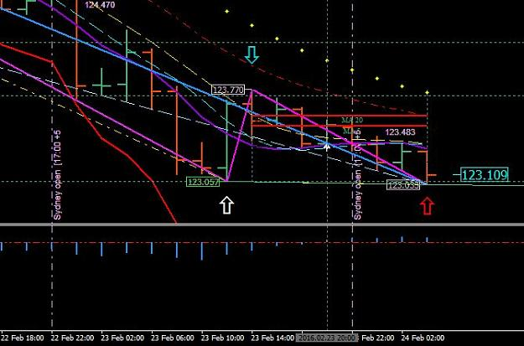
http://www.forexfactory.com/attachment.php?attachmentid=1863838&stc=1&thumb=1&d=1456293118
Going into the second week of training I had stated that DB/SAR is to be deleted off the 1 hour chart. And the reason is because the DB/SAR does not belong on the 1 hour chart. I also stated that I had placed it there thinking it may help to recognize support and resistance and because of the confusion it was my mistake in doing that. So, again delete the DB and the SAR off the 1 hour chart.
For those who may be confused - the DB is the SwingHighLow.
..................................................................................................................................................................................
Quoting lkh81
{quote} The sage has spoken, i have to work. But i didnt keep a copy of what i was seeing 3 hours ago. So when i reloaded the MT4(as i was about to shut down my PC for the day), the graph is a little different now. For H1: I am sure there isnt any BB. The lower end of DB is 0.71631 instead of the 0.71294 now. I've seen a few times DB moved lower and In consolidation i believe it will touch and go. but i dont think this is a consolidation(ROMAR is consistent on all 3 charts). But anyway DB should be disregarded since it is H1 chart H1 {image} For...
That is correct - there is no support on a trend. Only in consolidation. That is why 40 is your limit for both trend and consolidation. And on the 1 hour delete the DB and SAR.
..................................................................................................................................................................................
I am going to get into the DB/SAR at this time so the rest of the week you can study it. And the DB/SAR is ONLY for the 2 hour and the Daily Charts. If you place it on the 1 hour you will have some major problems trying to trade it.
The DB is only a trend indicator and has no value what-so-ever with the Paradox. BUT - it is a tool for the SAR and that is where the value comes in.
In trend the DB will paint from candle to candle of lower/low in the downtrend and higher/high in the uptrend. And the price tag that is showing with the DB in Thistle is the SAR - and not the DB. So in consolidation both DB and SAR are running together with the DB showing the SAR behind the DB and not showing.
In consolidation when the DB is showing with the price tag you pretty much have an entry. Lets say you have a hit on support in consolidation and the DB (with the price tag) connects with the bottom of the support candle you then have a reversal on the swing. Same thing vice-versa. But you always want to wait for the next open 2 hour candle for an entry. In consolidation you could get the next candle to bump Higher/High or Lower/Low depending on trend of the swing and move to the next candle. But - you have a 40 stop and that will hold until the reversal. But other times it would just take off on the next candle for the reversal.
In trend is a totally different picture.
So let me talk about the downtrend since we are in one. In the beginning of a downtrend you have both the DB/SAR attached to the upper candle with the Fibo 0%. 90% of the time the SAR will be the one to break loose from the DB and attached itself to the bottom of a candle. On the next candle - if the DB does not attach itself with the SAR then the SAR is set in stone - it will not repaint. The market will reverse and the SAR will reattached to the top of the next 1-3 candles for an entry back into the trend. And if the Parabolic is in that trend then it will attached itself at the Parabolic.
Once the downtrend is in full bloom then the DB and the SAR will eventually attach to a bottom of a candle (together) in the trend. And it will continue in the trend - together - from lower/lows. Eventually the Fibo will flip with the "0" on the bottom indicating an oversold market. But depending on trend it could very well keep going lower/lows if the trend is that strong. Towards the ending of the trend you will have the SAR break away from the DB and attached on an upper retrace candle. That SAR attachment is also set in stone indicating an entry back into trend and reattaching with the DB.

Once that happens you will then be looking for a reversal of the trend. But consolidation is in the horizon for the reversal and could consolidate for many hours before it does reverse. And you can recognize this with the bumping of the 0%.
This is the basic and next week we will get more into the DB and the SAR.
Another thing I forgot to mention is an indication of a reversal on trend: And that is when the Fibo relocates. If you take notice at this time the Upper Fibo had relocated from its original high to a new lower high.
And that is only on the 2 hour chart.
Little by little you will come to recognize the Power of this system.
Some of you may not see it at this time with Fibo - but will see it the next time you reboot the MT4. This is one reason you always reboot after the 17:00 EST opening - to reset your data.
Some of you will be looking for a reversal after 17:00 for your trading plans. Keep in mind the reversal is only with the swings and not the ROMAR trend. It will be awhile before that happens.
..................................................................................................................................................................................
Quoting Contrax
{quote} What you mean about "Relocate", Master ?
The original high for the downtrend was at 125.888 and is now located at the 125.553. That is what I mean.
..................................................................................................................................................................................
Quoting goldtime
{quote} Mr. Dana, so it is actually we must pay attention to SAR and DB changes as the first sign of reversal event, not ROMAR at all, ROMAR comes second, please correct my understanding. thank You
What did I say about the DB/SAR?????? It has nothing to do with creating a trading plan at this time.
..................................................................................................................................................................................
Quoting goldtime
i got too excited with the sar and db, assuming that this is the most accurate indication for reversal event
goldtime -- you cannot assume anything. The DB/SAR is a totally different scenario when it comes to trading. And that is why I have not brought it up until now. But in order to trade the DB/SAR you first must learn how to trade. And as far I can see - you are not there yet.
..................................................................................................................................................................................
Quoting Cherry
Does anyone know if the 40 bars includes Sunday bars or not? I've just discovered a fib difference between two platforms because one is now doing Sunday bars. This of course makes the position of the last high / low different between the two charts. Thanks. Oh and it also seems to change the position of the cross on a daily chart. eg cadchf purple / white has crossed on the 6 bars a week chart and but not quite on the 5 bars week chart. Sorry that pair as an example... know this is a EJ thread.
- OK Cherry - on the Daily will depend on the brokers open/close time. So there will be a slight difference until the next Daily bar. And if you notice - there is nothing with the system that includes a weekly chart.
..................................................................................................................................................................................
Quoting JMaurice
{quote} Thank you for your review and your comments. I have always been very private, but privately trying to teach myself how to trade has not worked. I am usually very good at everything I do and never ask for help, and figured I could 'wing' it in trading. That has not worked in this endeavor, however.
I do understand that well - as I am the same. Sometimes we have to admit there is a Power greater then ourselves.

25 Feb 2016

Quoting snfx
maybe to early short @ 123,814
Do not post another multiple trade. This is not about greed but learning in how to trade. Learn to walk away from a profit until the next day or your greed will catch up with you and take you down.

Never go searching for another trade after you had made your profit. For one thing you no longer have a trading plan and secondly; you need time to recoup from a trade - either a winner or a loser. Your emotions are too stressful to trade again until the next day. Always remember that.
..................................................................................................................................................................................
Quoting Contrax
{quote} Im going to print that and tape in to my monitor. One question Master: If you have a Win, obviously ur daily goal is completed and you wait for new Day. But... If u have a loss, we do the same thing? I mean we only place one trade per day? Win or Loss.. we dont trade until next day?
That is correct - win or lose; that is especially true if you lose. The emotions from trading alone places you in a critical state of focus, and logic. And it does take a day to recoup both focus and logic so you are in the right frame of mind to trade again.
..................................................................................................................................................................................
Most of the problems is not recognizing the Fibo. You had the 61.8 as a barrier and when it was hit - a retrace back to EMA; and then heading back to the 61.8. You are in a consolidated uptrend with ROMAR as the trend. By trading in the moment you check the bar from top to bottom including the bars on the MACD for lower/low or higher/high. You have to see the whole picture on the bar before trading. You have EMA and Parabolic's in the trend and it is up heading for ROMAR but you have know where the retrace is going to happen. And the Fibo gives you the reference for those retraces. So keep in mind that the Fibo is also target areas.
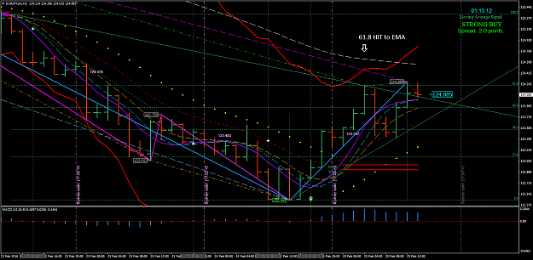
http://www.forexfactory.com/attachment.php?attachmentid=1865366&stc=1&thumb=1&d=1456411721
..................................................................................................................................................................................
Quoting JMaurice
{quote} Dove, I am assuming there are multiple ways of entering, not just one. Sure, it can be generalized as buy at support and sell at resistance, but I believe that my original assumption - that there were exact defined entries that everyone would see and everyone would use, all our trades would be identical - is not true, and entries will depend on the trader? Or are we still all learning and ultimately will all realize that there is really only one logical entry per every swing and will all end up taking that one?
That is where you are wrong. All the Basic entries are the same - you just have to recognize them. And that is with Purple/White and Smooth. Then there are the variables for entries in which I have been teaching everyone.
..................................................................................................................................................................................
Quoting JMaurice
{quote} Thank you for the response - I just get confused when I see people doing things I didn't see, and by no means do I see everything, but its hard to know sometimes if what is being done is correct or not.
Some break the rules and that is the way of life. Just stay with the basics and work with the variables and eventually it will all come together. But trading in the moment is the important part - not what other's are saying. That is when intimidation takes over.
..................................................................................................................................................................................
All you need to know when it comes to your accounts is 40 pips a day compounding can make you very wealthy. Breaking the rules is not going to get you there. All it will do is place conflicting scenarios that are not in reality.

I am at the point of doing one of three things with those who love to break rules.
1 - Bump you off the thread.
2 - Just give up because of too many rules being broken.
3 - Take those who wants to learn into my personal forum.
That will be entirely upon you guys in what I do. With those who break the rules are ruining it for those who are trying to follow the rules. Too much intimidation in trying to boost your ego.
..................................................................................................................................................................................
Quoting rcbarlow
Some people seem to be overlooking one simple thing: Your entry chart trend is Smooth.
Thank you for bringing that up.
..................................................................................................................................................................................
Like RC had brought it up - Smooth; I have shown you trades in how Smooth works with both sliders and crossings. How to recognize sliders with White as reference. Also how to recognize EMA as trend for swings with Purple crossings and sliders over/under Purple. These are precise entries that revolutionize the Paradox over and over again. The 4 horsemen are your trading tools for entries and exits. They work together as support and resistance giving the visual of exactly what is happening in the market.
When you try to trade in old school thinking then your vision is not correct with the Paradox. When you try to enhance the Paradox with outside resources then you are on the wrong journey. You have to compel yourself with a different attitude in seeing outside the box. Staying inside the box only takes away what is necessary in seeing the whole picture.

